.

**Adobe DAM Support**

**Standard Operating Procedure**



|  |  |
| --- | --- |
| Project | Adobe DAM Support |
| Company | eClerx Services Ltd. |
| Prepared by | Sumit Bhawsar |

This document is copyright protected in content, presentation, and intellectual origin, except  
where noted otherwise. You may not modify, remove, augment, add to, publish,  
transmit, participate in the transfer or sale of, create derivative works from, or in any way exploit any of the elements of this document, in whole or in part without prior written permission from eClerx Services Ltd. © 2010-2011.

**Table of Contents**

**Table of Contents** 3

**List of Tables** 6

**List of Figures** 7

1. Process Overview 9

1.1. Process Introduction 9

1.2. Business Context 9

1.3. Adobe Operational Definitions 9

2. Publishing New Assets in DAM 11

2.1. Introduction 11

2.2. Process Flow 11

2.3. Process Tools 11

2.4. Input 11

2.4.1. Input Documents 11

2.4.2. Sender of Input Documents 12

2.4.3. Location of Input Documents 12

2.4.4. Naming Convention of Input Documents 12

2.5. Procedure 12

2.5.1. How to Publish Assets on Marketing Hub 12

2.5.2. How to create a New Folder 48

2.6. Interlinks within eClerx processes 51

2.7. Output 51

2.7.1. What is the Output? 51

2.7.2. Whom is it sent to? 51

2.7.3. Where is the Output Saved? 51

2.8. Checklist 51

3. New Account Creation in Adobe Marketing Hub 53

3.1. Introduction 53

3.2. Process Tools 53

3.3. Input 54

3.3.1. Input Documents 54

3.3.2. Sender of Input Documents 54

3.3.3. Location of Input Documents 54

3.3.4. Naming Convention of Input Documents 54

3.4. Procedure 54

3.5. Checklist 72

4. Error messages - Canned responses 73

4.1. Vendor Logging in as an Adobe Employee 73

4.2. Search and Filters Not Visible on Asset Finder Page (Internet Explorer) 73

4.3. Downloads Appear to Disappear 74

5. Employee user support - Canned responses 75

5.1. Internal Login Instructions 75

5.2. How Do I Get an OTP Token and Create a PIN? 75

5.3. How Do I Change my PIN? 75

5.4. Request for Premium Access/Full License 76

6. Vendor user support - Canned responses 77

6.1. Vendor Request for Access 77

6.2. Request to Stakeholder for Confirmation of Vendor Eligibility by Adobe Contact - 1 77

6.3. Request to Stakeholder for Confirmation of Vendor Eligibility by Adobe Contact - 2 78

6.4. Request to Stakeholder for Confirmation of Vendor Eligibility by Adobe Contact - 3 78

6.5. Reply to Stakeholder after Confirmation Received (& Vendor Account Approved) 78

6.6. Account Request Workflow Missing Details 78

6.7. Vendor Request for Company & Stakeholder Info 79

6.8. Vendor Request for Company & Stakeholder Reminder 79

6.9. Vendor Request for Access Denied Due to Incomplete Info & No Response from Requestor 79

6.10. Vendor Request for Access Denied by Stakeholder 79

6.11. Vendor Request for Access Denied Due to No Response from Stakeholder 80

6.12. Reset a Vendor Password 80

6.13. Vendor can’t log in using IE10 80

6.14. For Generic Account (Name & Email ID) 81

6.15. Sharing MH Accounts 81

6.16. Partner Portal 81

7. Publisher user support - Canned responses 82

7.1. Error when Creating a Folder 82

7.2. Error when Deleting an Asset 82

7.3. Error when Moving an Asset 82

8. Publishing questions - Canned responses 83

8.1. How can I get new asset published to the Marketing Hub? 83

8.2. How do I get my assets published to Partner Portal and/or Readiness Portal? 83

8.3. How do I publish assets to the Marketing Hub? 83

9. Adhoc Task 84

9.1. Expired Users – External 84

10. Registered Partner Questions - Canned responses 85

10.1. Can my partner get access to the Marketing Hub? 85

11. Tips and Tricks 86

11.1. Asset download from Asset Finder 86

12. Revision History 87

**List of Tables**

Table 1: Operations Definitions 10

Table 2: Operations Definitions 26

Table 3: Marketing Hub Language Abbreviations 47

Table 4: File Formats 48

Table 5: Asset Upload Checklist 52

Table 6: Revision History 85

**List of Figures**

Figure 1: Publishing New Asset Process Flow 11

Figure 2: Request Email - JotForm 12

Figure 3: Request Email - WorkFront 13

Figure 4: Adobe Marketing Hub 14

Figure 5: Adobe Marketing Hub Login link 15

Figure 7: Login Credentials 16

Figure 9: Sign In Page 16

Figure 10: Create Adobe ID 17

Figure 11: Adobe Marketing Hub Home Screen 17

Figure 12: Author Button on Adobe Marketing Hub Home Screen 18

Figure 13: Adobe Marketing Hub Author Execution Area 18

Figure 14: Adobe Marketing Hub Navigation Tree 19

Figure 15: Adobe Marketing Hub New Asset Uploading 20

Figure 16: New Asset on Adobe Marketing Hub 21

Figure 17: New Asset Property Page 21

Figure 18: New Asset Metadata Page 22

Figure 19: New Asset Metadata Fields 22

Figure 20: Marketing Hub Shortcuts 23

Figure 21: Metadata Field - ASSET TYPE 24

Figure 22: Metadata Field – USE RESTRICTIONS 25

Figure 23: Metadata Field - LEGAL EXPIRATION 25

Figure 24: Metadata Field - USE STATUS 26

Figure 25: Metadata Field – KEY WORDS 27

Figure 26: Metadata Field - VERTICAL INDUSTRY 27

Figure 27: Metadata Field - PRODUCTS/SERVICES 28

Figure 28: Metadata Field - PRODUCT VERSION 28

Figure 29: Metadata Field - LANGUAGE 29

Figure 30: Metadata Field - ASSET OWNERS 29

Figure 31: Metadata Field - CREATOR 30

Figure 32: Metadata Field – OTHER CREATOR 30

Figure 33: Metadata Field – PROJECT NUMBER 31

Figure 34: Metadata Field – PART NUMBER 31

Figure 35: Metadata Field - TARGET GEO/REGION 32

Figure 36: Metadata Field - PUBLISH TO READINESS PORTAL 32

Figure 37: Metadata Field - PUBLISH TO PARTNER PORTAL 33

Figure 38: Sales & Marketing Content Policy Matrix 33

Figure 39: Metadata Field - WRITE ACCESS 34

Figure 40: Metadata Field - SAVE/UPDATE 34

Figure 41: PUBLISH BUTTON FOR NEW ASSET 35

Figure 42: Send Email to Requester with asset Id and title 35

Figure 43: WorkFront Publishing Request Form Field 37

Figure 44: Custom Form 38

Figure 45: Marketing Hub Publish Request 38

Figure 46: ASSET DETAIL PAGE 39

Figure 47: RENDITIONS PANEL 40

Figure 48: UPLOAD RENDITION ICON 40

Figure 49: EDIT RENDITION TITLE 41

Figure 50: NEW VERSION ICON 42

Figure 51: VERSION PANEL 42

Figure 52: ACTION ICON 43

Figure 53: UPLOAD FILE ICON 43

Figure 54: NEW VERSION CREATED 44

Figure 55: NEW VERSION CREATED 44

Figure 56: BULK UPDATE 45

Figure 57: BULK METADATA EDITOR 45

Figure 58: BULK ASSETS MODIFIED WINDOW 46

Figure 59: BULK ASSETS MODIFIED WINDOW 46

Figure 60: REVERT ICON 46

Figure 61: REVERT WINDOW 47

Figure 62: Folder Tree 49

Figure 63: Folder Name and Title 49

Figure 64: New Folder Page 50

Figure 65: New Account Creation Process Flow 53

Figure 66: Workflow Notification 55

Figure 67: Marketing Hub 56

Figure 68: Model Filter 57

Figure 69: IMS User Creation 57

Figure 70: Workflow Title 57

Figure 71: Adobe Hub – Employee Directory 58

Figure 73: Approved By Details link 59

Figure 74: Approved By 59

Figure 75: Complete Button 60

Figure 76: User Approval Status 61

Figure 77: Comment and Ok Button 62

Figure 78: Auto generated Mail 62

Figure 79: Edits Profile Button 63

Figure 80: Save User Info Button 64

Figure 81: User Approval Status 65

Figure 82: Comment & Ok Button 66

Figure 83: Auto generated mail 66

Figure 84: User Approval Status 67

Figure 85: Comment & Ok button 67

Figure 86: Auto Generated Mail 68

Figure 87: New User 69

Figure 88: Login ID 70

Figure 89: User Group 71

Figure 90: Re-activation 71

Figure 91: User Activation 72

Figure 92: Compatibility view mode 74

Figure 93: Compatibility view mode 81

# Process Overview

## Process Introduction

The Adobe Marketing Hub is the global repository for Adobe marketing assets. Assets maintained here can be [delivered to Adobe's sales portals](http://partnerdownload.adobe.com/p/inf_pp_transfer_overview.pdf), Readiness Portal and the Adobe Partner Connection Portal. The Marketing Hub provides additional features including the ability to report on marketing activities, open new project numbers and access project management tools

## Business Context

Adobe is the global leader in digital marketing and digital media solutions. Tools and services enable Adobe’s customers to create groundbreaking digital content, deploy it across media and devices, measure and optimize it over time and achieve greater business success. Adobe help the customers make manage measure and monetize their digital content across every channel and screen.

Digital media

Adobe helps creative professionals, publishers, developers, and businesses create, publish, promote, and monetize their content anywhere.

Digital marketing  
Adobe helps major brands and agencies create, manage, and optimize their digital marketing across channels for maximum return on investment.

eClerx has wide range service offerings pertaining to asset management. eClerx Adobe DAM support team is involved in account management, asset management and production support on Adobe Marketing Hub portal (DAM).

## Adobe Operational Definitions

|  |  |
| --- | --- |
| **Term** | **Definitions** |
| Marketing Hub | The Marketing Hub is the executive-approved global repository for Adobe marketing digital assets, including all creative files, templates, and brand guidelines. Its functionality includes the capability to store, manage, search and retrieve, and report on digital asset use. |
| Adobe Connect | Adobe’s web conferencing tool. |
| InterCall | Adobe's standard for voice conferencing. |
| Readiness Portal | Readiness Portal intranet housing collateral pertaining to Digital Media products (Creative Suite and Acrobat), LiveCycle, Adobe Connect and Print & Publishing products (eLearning Suite, Technical Communication Suite, Captivate, Presenter, FrameMaker/FrameMaker Server, and RoboHelp/RoboHelp Server). Also houses operational content such as Enterprise Lead to Order/Salesforce.com, price lists, and compensation plans. |
| Jabber | Adobe internal Instant Messenger solution (compatible with Windows XP) |
| Sales Collateral Portal | Field intranet housing collateral specific to the Digital Marketing Suite |
| Adobe Partner Connection Portal (aka Partner Portal) | Collateral portal supporting Channel partners, Training Providers, Influencers, and Technology Partners. Product content is restricted to Digital Media, Adobe Connect, and Print & Publishing. Doesn’t include LiveCycle or Digital Marketing Suite assets. |
| SendNow | Let’s you send, share, and track large files online. |
| Inside Adobe | Adobe Intranet providing an overview on all the different groups and portals |
|  |  |

**Table 1: Operations Definitions**

# Publishing New Assets in DAM

## Introduction

The Adobe Marketing Hub’s Digital Asset Management module allows you to post creative assets with multiple renditions for download. It also allows you to easily update an asset with a new version. In order to begin posting an asset to the Marketing Hub, first prepare the files for uploading by renaming them on your hard drive using “Adobe’s Digital Asset Naming Guidelines”. In addition, discuss all the relevant metadata to be added to the asset with the asset owner.

## Process Flow



Figure 1: Publishing New Asset Process Flow

## Process Tools

* Marketing Hub: <http://www.adobe.com/marketinghub/>

## Input

### Input Documents

* Asset request details via e-mail

### Sender of Input Documents

* Adobe Vendors
* Adobe Stakeholders
* Rebecca Paduraru

### Location of Input Documents

* Outlook

### Naming Convention of Input Documents

* NA

## Procedure

### How to Publish Assets on Marketing Hub

1. Once we receive asset uploading request via email.

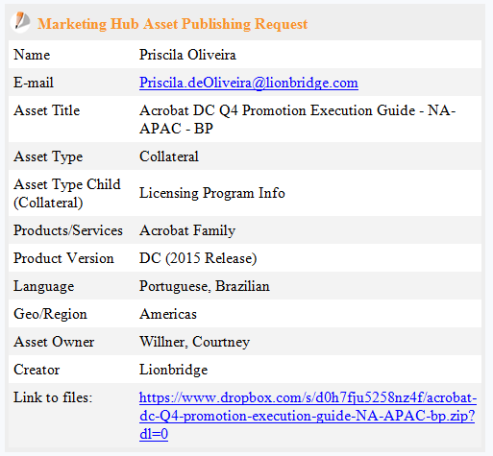

Figure 2: Request Email - JotForm

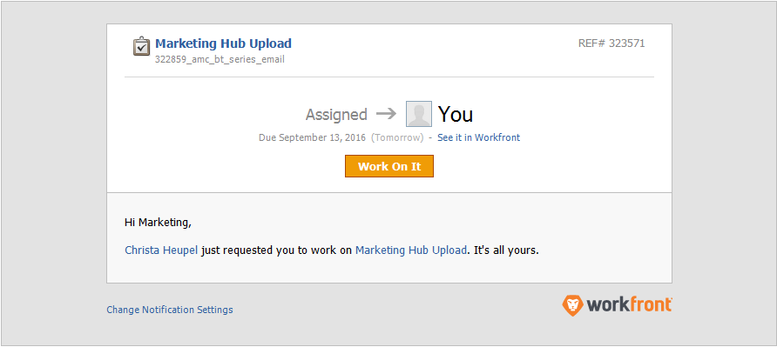

Figure 3: Request Email - WorkFront

Author initiate with input validation & if any input are missing author get back to the requestor & ask for missing details.

1. Download all given asset(s) in local machine which need to be uploaded on Adobe marketing Hub.
2. Once the author proceeds with the asset uploading process he/she needs to open the Process checklist for detail actions.
3. Rename asset files to abide Adobe’s Digital Asset Naming Guidelines

Asset File Naming Convention Guidelines:

DEFINITION:

The file name is the name of the actual file that is downloaded from the Marketing Hub.

NOTES:

Rename your asset file names before publishing assets to the Marketing Hub

Keep your users in mind—use descriptive file names so they can easily identify the file once saved to their system

Do not use vendor-specific naming systems (i.e. vendor’s project number)

Please use underscores to keep file names readable

EXAMPLES:

dreamweaver_cs5_channel_copy_ue.pdf

education_cs5_student_teacher_edition_back-to-school_postcard_s.zip

flash_player_10_mnemonic_no_shadow.ai.

1. Generate a Meta data & check if any confirmation is required from requestor. In case any mandatory information is missing or any critical data needs to double confirm send an email to requestor for confirmation & once you receive the confirmation proceed further.
2. Open below Adobe Marketing Hub URL in Mozilla Firefox

<http://www.adobe.com/marketinghub/>

Supported browsers: Internet Explorer 7, 8 or 9 (32-bit mode), Safari 4 or 5 and Mozilla Firefox 10 to 16 supported.

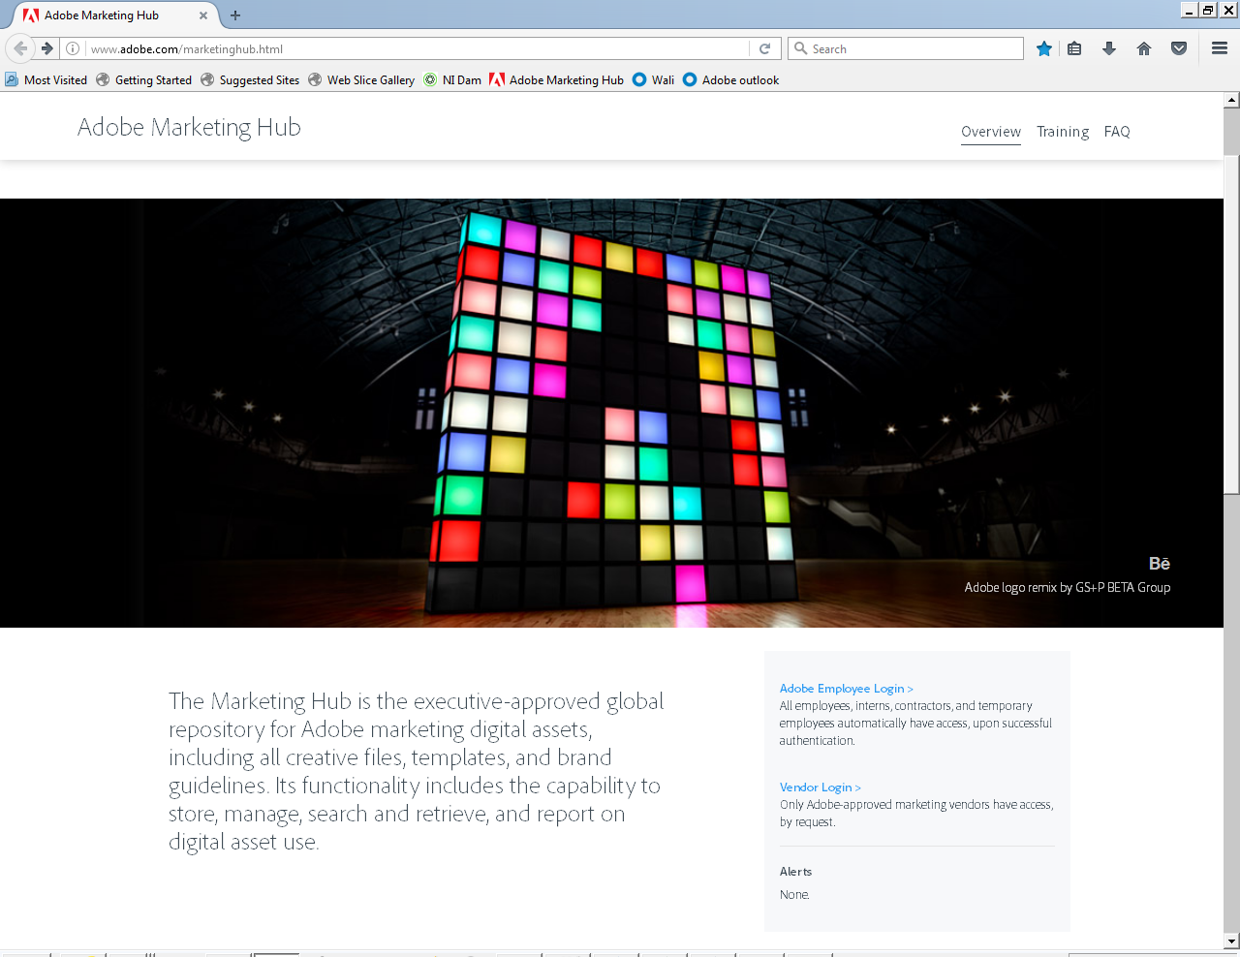

Figure 4: Adobe Marketing Hub

1. eClerx resource can login into Adobe Marketing Hub by clicking on both as an Adobe Employee or as a vendor.

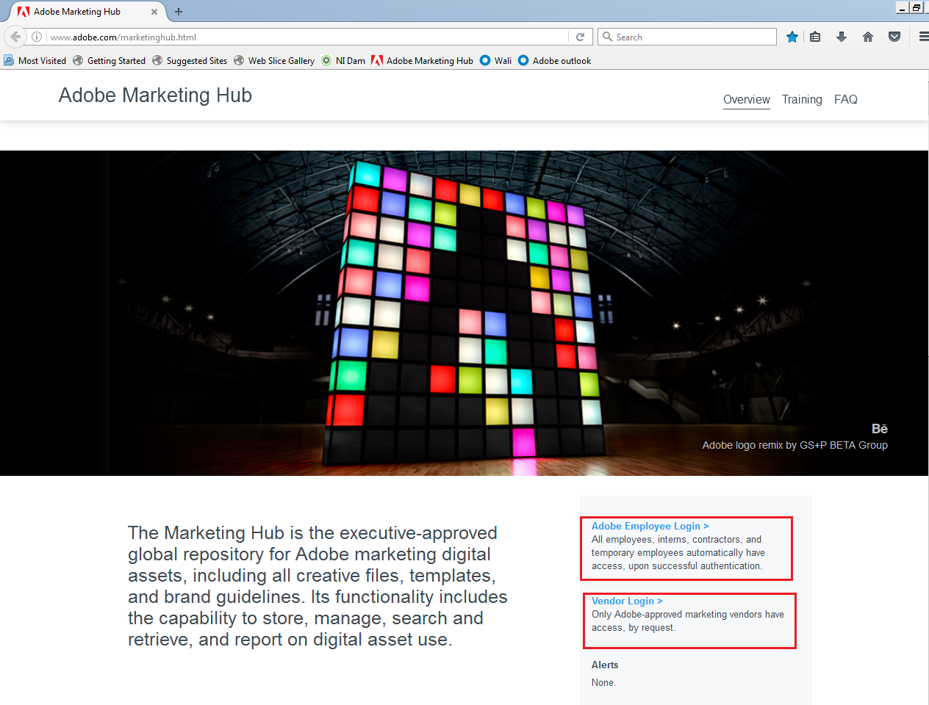

Figure 5: Adobe Marketing Hub Login link

1. After you click on the Employee Login link
2. Clicking on Adobe employee you will get the below page. Now enter user ID and PIN+OTP and click Log In.

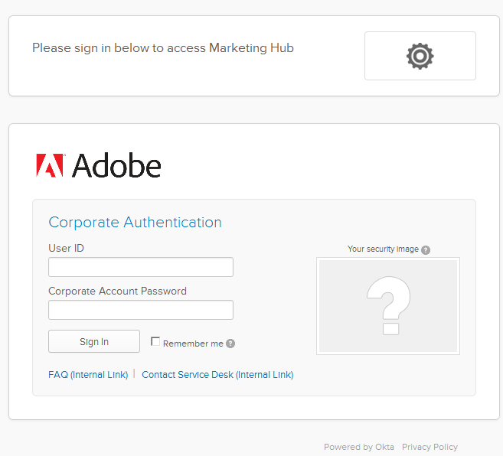

Figure 6: Login Credentials

1. Clicking on Vendor you will get the below page. Enter your Adobe ID & your Password & click on “Sign In”. If you don’t have Adobe ID created in the Marketing Hub. Click on “Create an Adobe ID”.

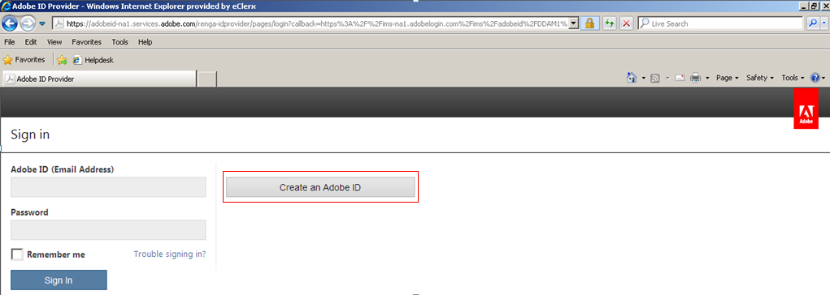

Figure 7: Sign In Page

1. Fill in the fields and click “Create” for your Adobe ID.

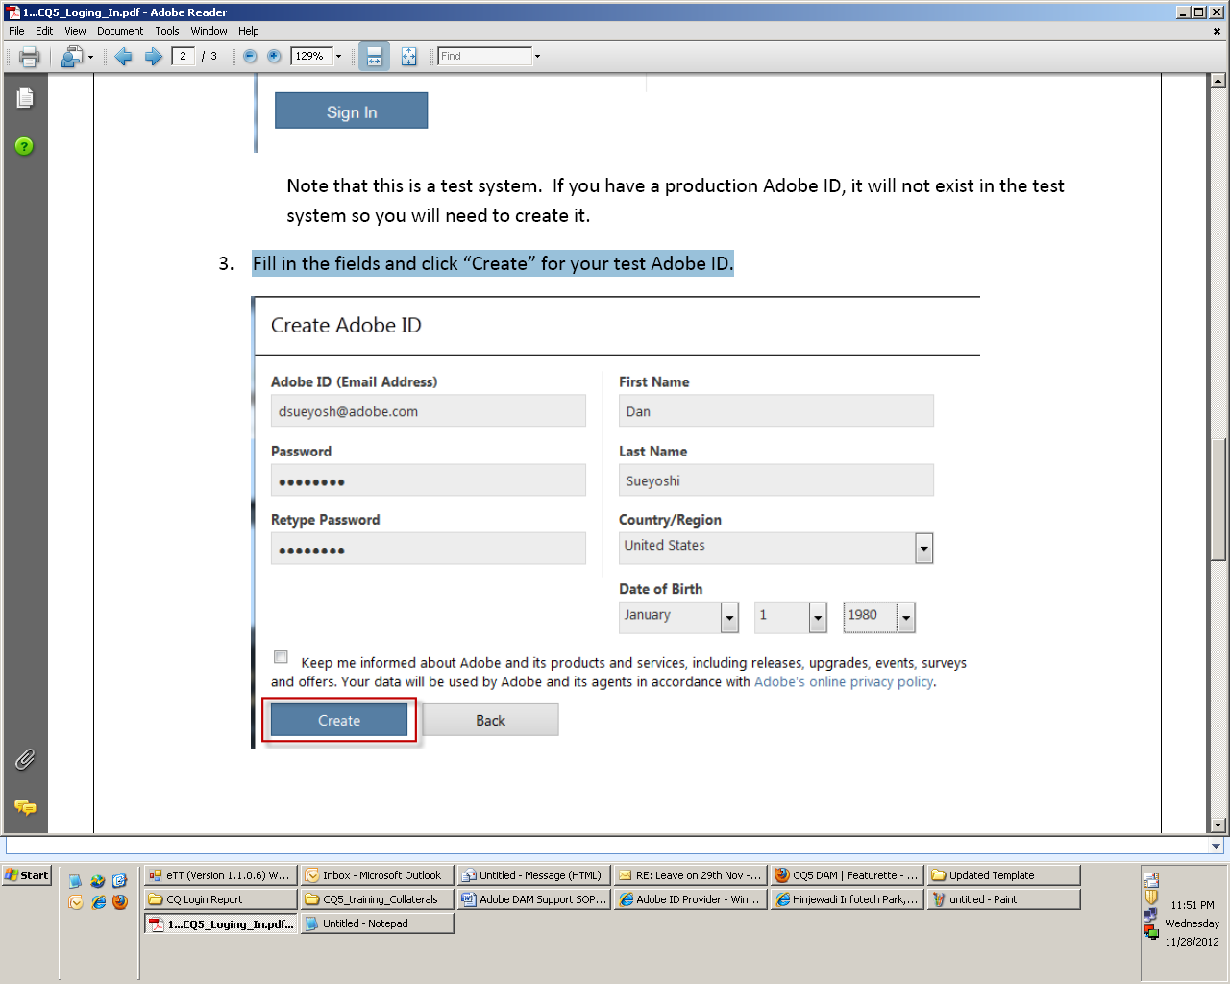

Figure 8: Create Adobe ID

1. You will be logged into the Asset finder page. This is the place where you can search the entire asset uploaded on Adobe Marketing Hub by using the search box and using the drop down menu’s Option.

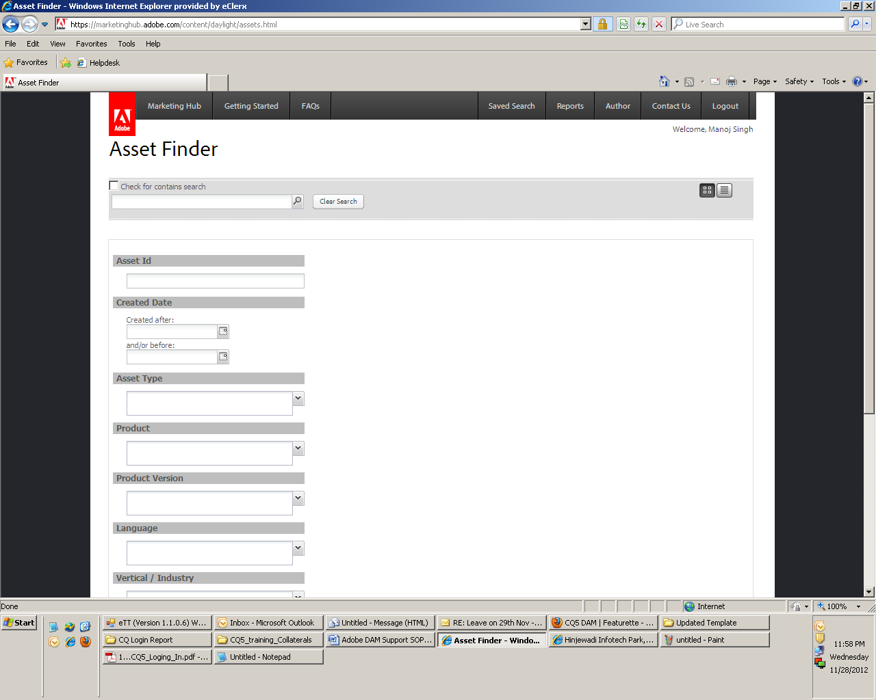

Figure 9: Adobe Marketing Hub Home Screen

1. For getting to the asset publishing area click on Author tab & get to Author Instance

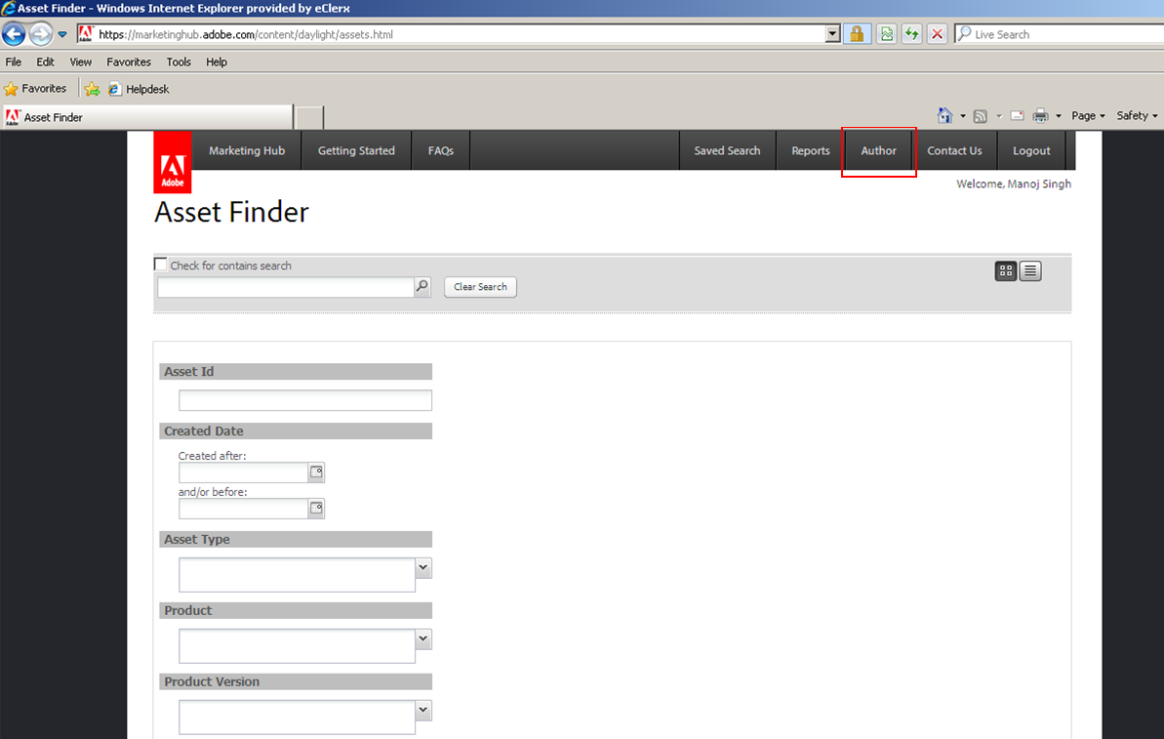

Figure 10: Author Button on Adobe Marketing Hub Home Screen

1. Once you click on Author Instance Marketing Hub execution area window will appear.

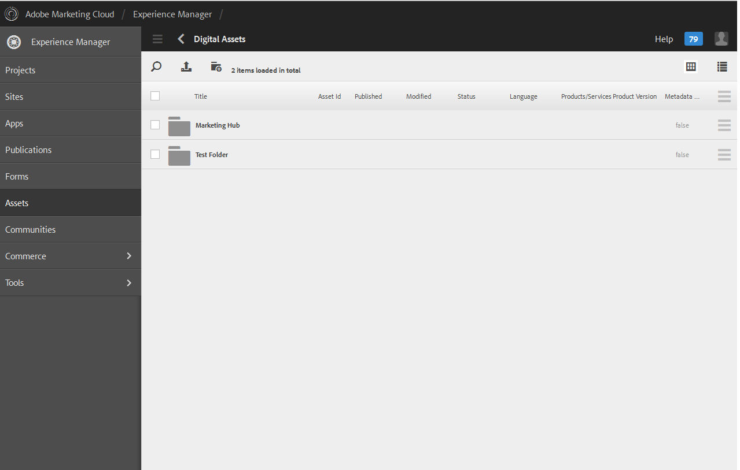

Figure 11: Adobe Marketing Hub Author Execution Area

1. Click on Marketing Hub folder to navigation tree; find the correct folder where you wish to publish your asset clicking on the folder name of the desired parent folder. Continue clicking on folders to expand the folder tree until you reach the desired sub-folder. When you see the folder you are looking for, click on it to select it.

Note: If the desired end folder is not present on Marketing Hub, we need to create a new folder following standard procedure & Adobe taxonomy sheet which has been briefly explained under section 2.5.2 (How to create a New Folder)

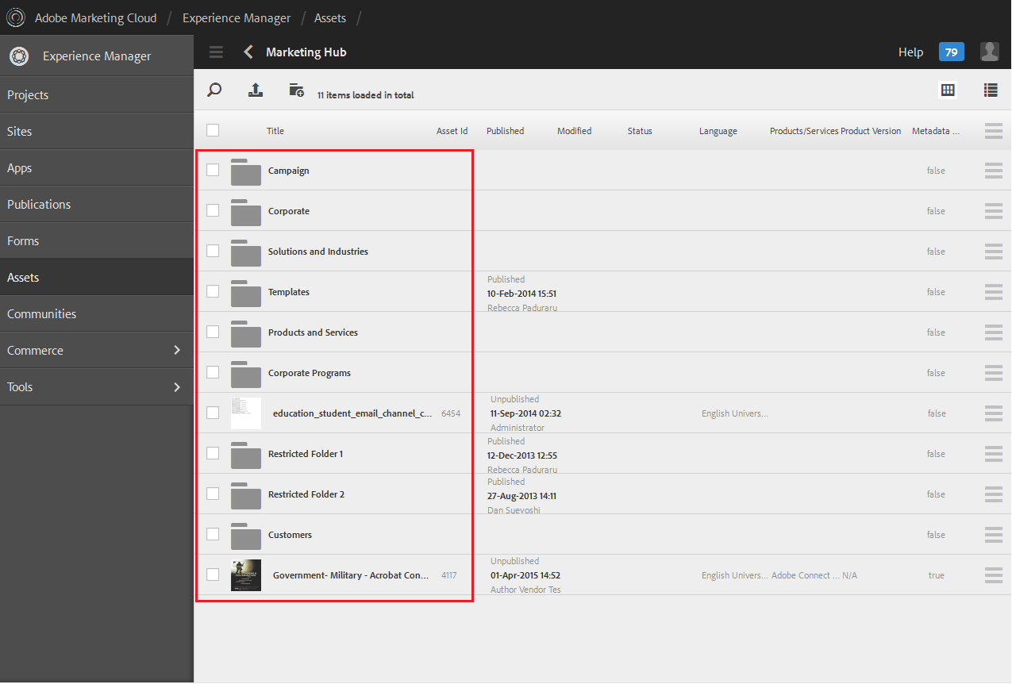

Figure 12: Adobe Marketing Hub Navigation Tree

1. Click the  button and browse to the file(s) that you wish to upload. You can select multiple files by pressing CTRL to upload multiple assets.

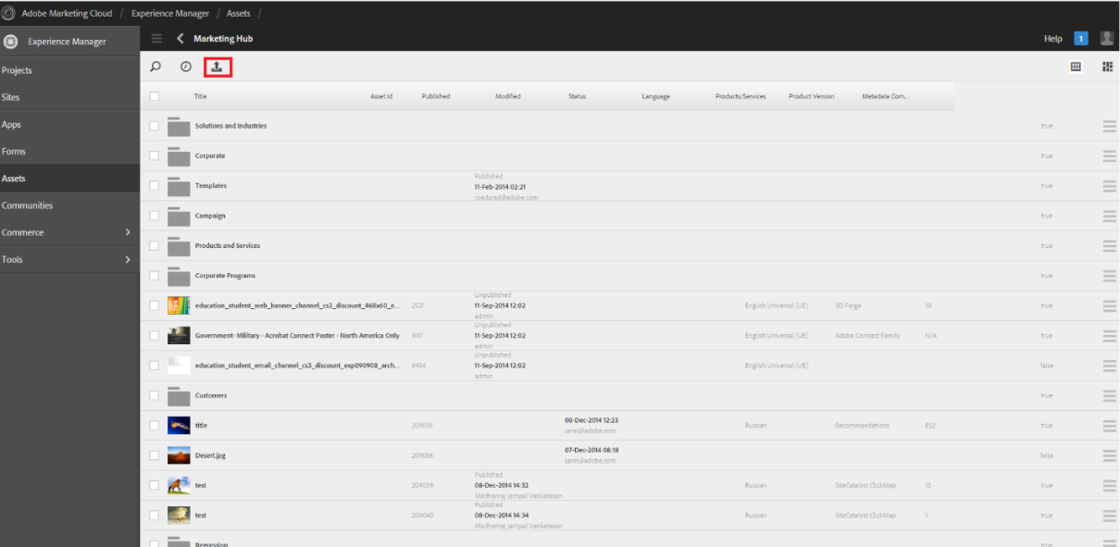

Figure 13: Adobe Marketing Hub New Asset Uploading

Note:

The files that you are uploading should only be the first rendition of the asset(s). To see the process for adding additional renditions.

1. When you add your first asset rendition, be sure that it is a file type that will generate a thumbnail in the system. A .pdf or .jpg are recommended formats to load when the asset file type does not generate a thumbnail
2. Update metadata – Click on asset to open or Select the asset and click on property icon from tool bar.

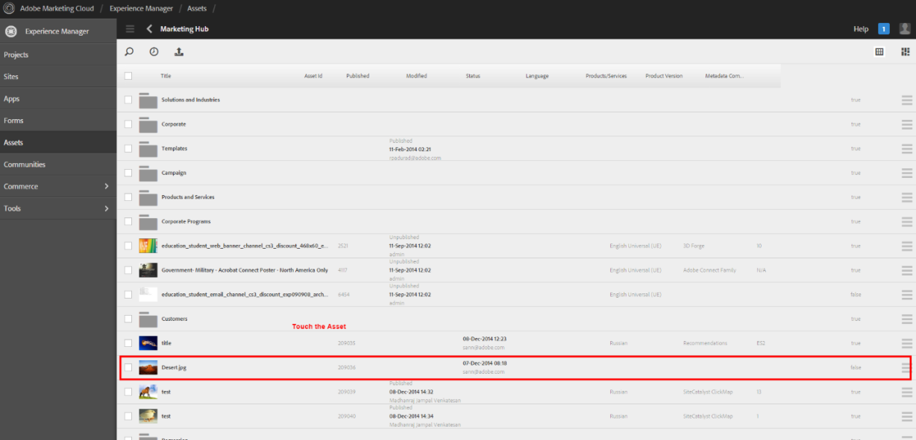

Figure 14: New Asset on Adobe Marketing Hub

1. Click the Eye icon on right corner and click the properties link will take user to the metadata form.

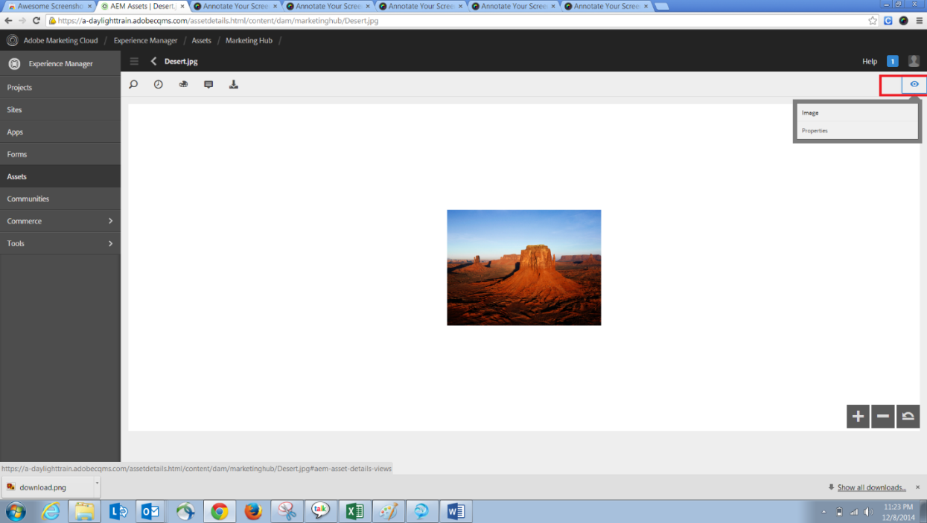

Figure 15: New Asset Property Page

1. Click the Pencil Icon to edit the metadata form

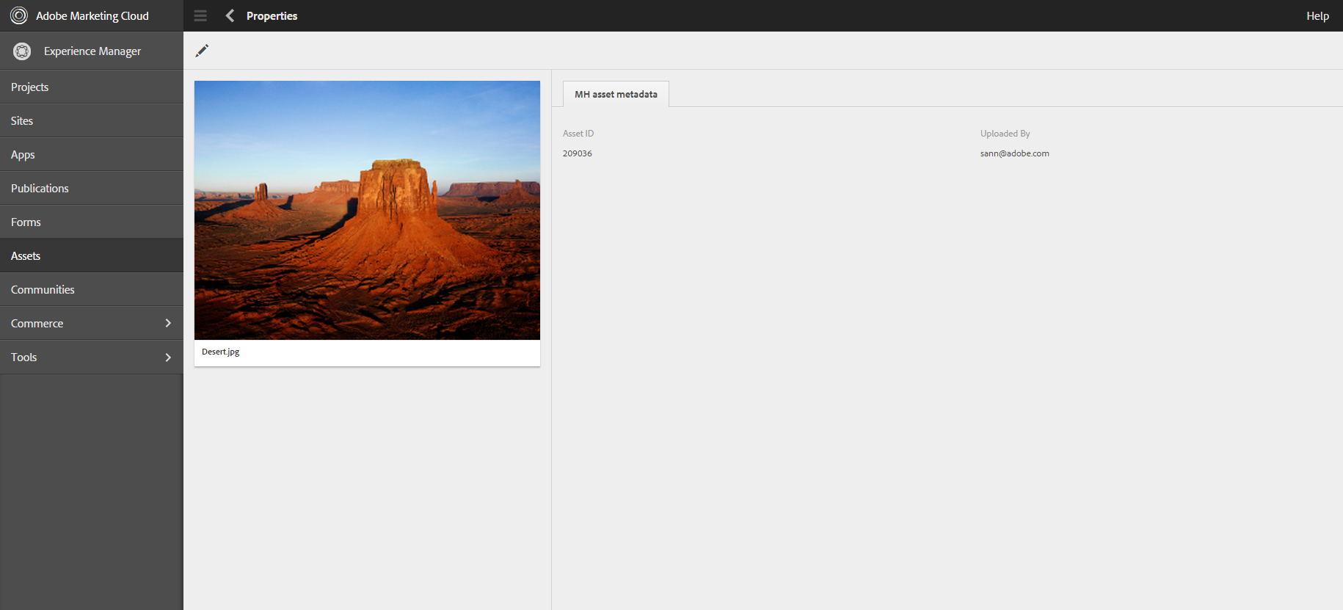

Figure 16: New Asset Metadata Page

1. Fill the metadata details on the form. At a minimum, fill in all the required metadata fields marked with an asterisk and highlighted in pink. The more metadata that you complete, the better chance the asset can be found easily in Asset Finder.

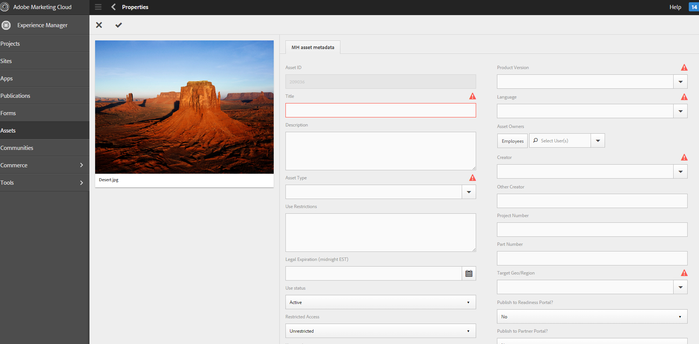

Figure 17: New Asset Metadata Fields

Metadata Details:

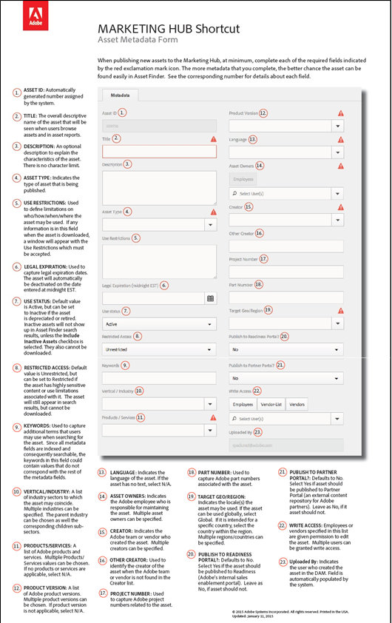

Figure 18: Marketing Hub Shortcuts

1. ASSET ID: Automatically generated number assigned by the system
2. TITLE: The overall descriptive name of the asset that will be seen when a user is browsing assets

NOTES:

* Use the “biggest to smallest rule” to create the asset title
* When applicable, include: Campaign, Program, Product/Service, Product Version #, Asset Type, Language, and specifics about this asset compared to a similar asset
* Do not include specifics about file type, color type, resolution, etc.
* Do not add underscores between words in the asset title

EXAMPLES:

* Acrobat XI Standard Totem – UE
* Education, Creative Suite 6 Student Teacher Edition, Back-to-School Flyer – UE Site Catalyst Product Overview – JPL

1. DESCRIPTION: An optional description to explain the characteristics of the asset. There is no character limit in this field.
2. ASSET TYPE: Indicates the type of an asset that is being published. Only one asset type can be chosen.

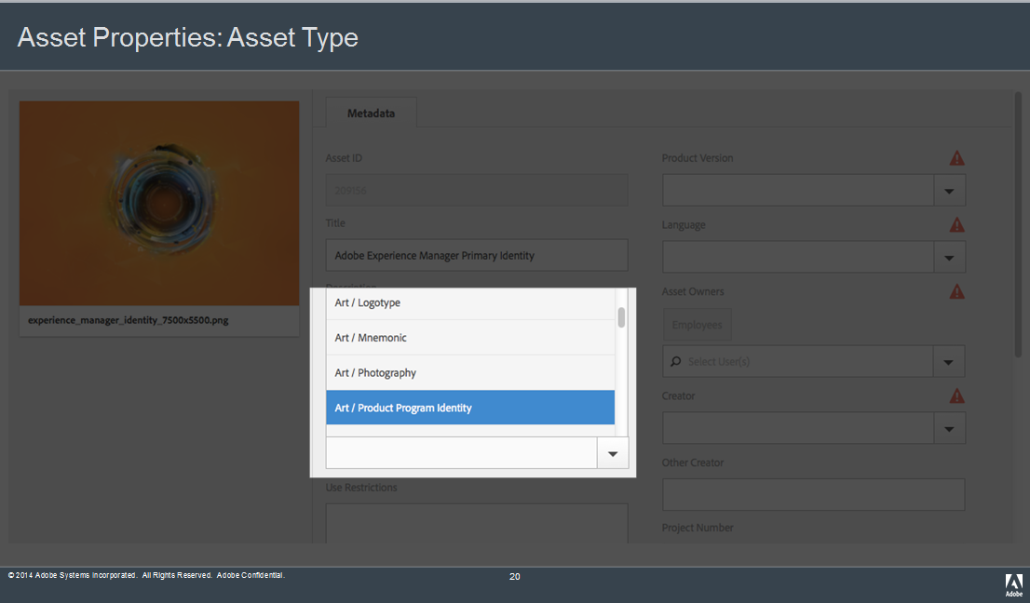

Figure 19: Metadata Field - ASSET TYPE

1. USE RESTRICTIONS: Used to define limitations on who/how/when/where the asset may be used. If any information is in this field when the asset is downloaded, a window will appear with the Use Restrictions which must be accepted.

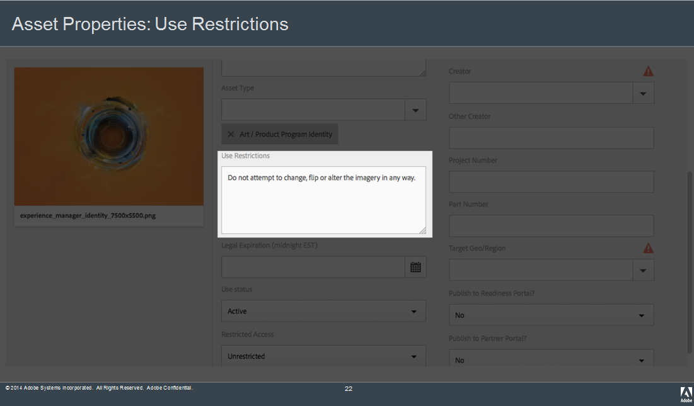

Figure 20: Metadata Field – USE RESTRICTIONS

1. LEGAL EXPIRATION: If the asset has a legal expiration date, enter date in this field. The asset will automatically be deactivated on that date.

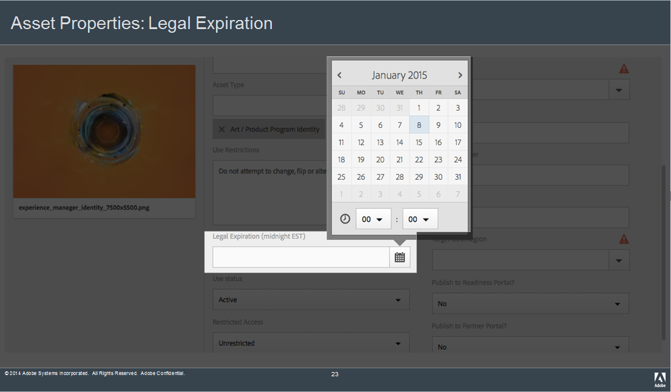

Figure 21: Metadata Field - LEGAL EXPIRATION

USE STATUS: The asset status can either be Active (default) or Inactive. Inactive assets will not show up in standard searches for assets; however, they still can be searched in Asset Finder if they Include Inactive Assets checkbox is checked.

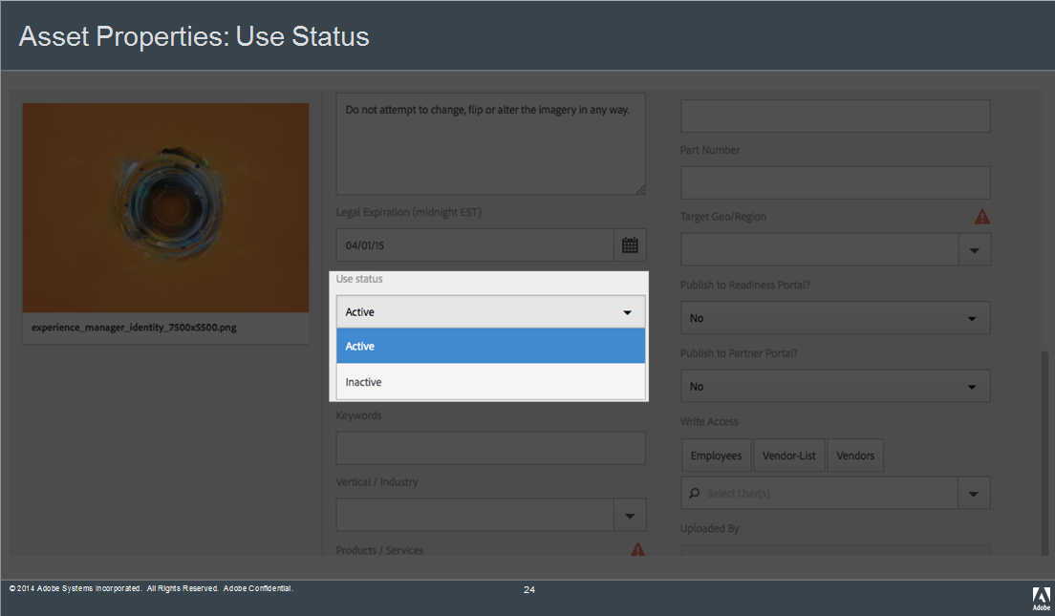

Figure 22: Metadata Field - USE STATUS

1. RESTRICTED ACCESS: Default value is Unrestricted, but can be set to Restricted if the asset has use limitations associated with it The asset is still able to be searched, but will require permission from the asset owner(s) to download.
2. Enter Use Restrictions if application after selection Yes or else select No

Note: Use Restrictions include legal limitations on how/when/where the asset may be used.

|  |  |  |
| --- | --- | --- |
| Abbr. | Use restriction definitions | Sample restriction notice |
| Notice | Third-party notice (if any) that Adobe must include when using the asset | Notice: © 2010-2011 Microsoft Corpora­tion. All rights reserved. |
| Exp | Date when Adobe’s license to use the asset expires | Exp: February 28, 2012 |
| Use | Limitations, if any, on how/where Adobe may use the asset | Use: Packaging only |
| Prods | Adobe products/versions with which the asset may be used | Prods: Acrobat X family |
| Terr | Territory where Adobe may use the asset | Terr: North America |
| Mod | Whether or not Adobe may make modifications to the asset | Mod: Cannot mod |

**Table 2: Operations Definitions**

1. KEYWORDS: Additional terms that users might use when searching for the asset. Since the system utilizes all metadata fields when searching, the keywords in this field could contain values that do not correspond with the rest of the metadata fields.

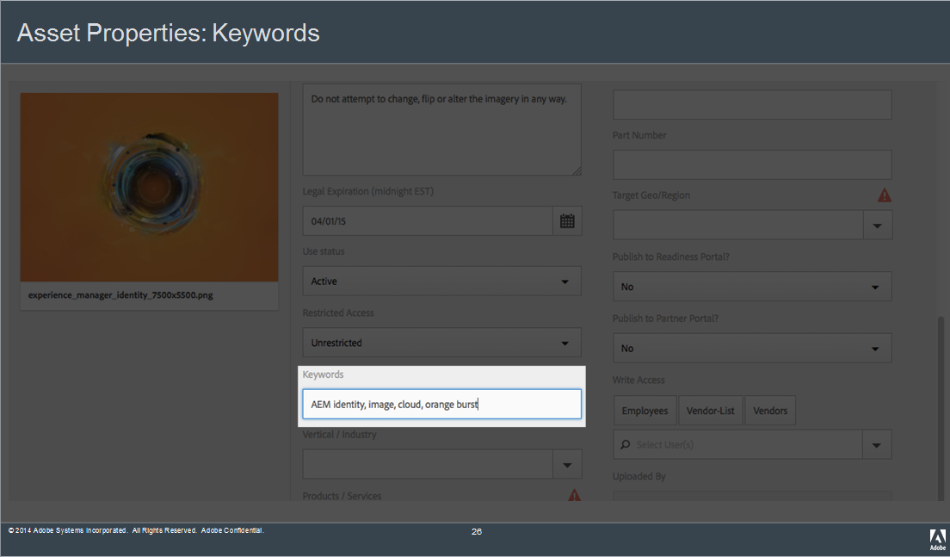

Figure 23: Metadata Field – KEY WORDS

1. VERTICAL INDUSTRY: A list of industry sectors to which the asset may coincide. Multiple industries can be specified. Additionally, the parent industry can be chosen as well the corresponding children sub-sectors.

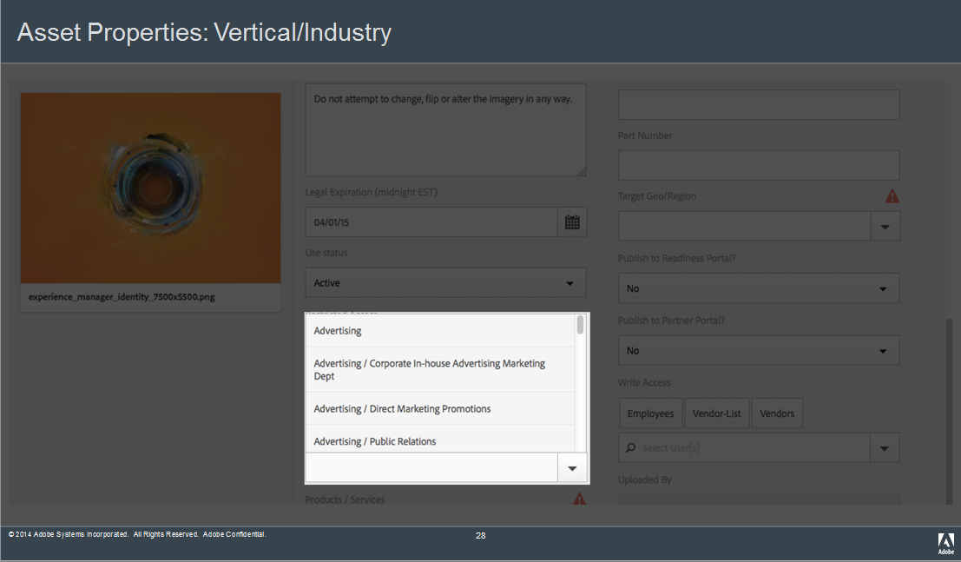

Figure 24: Metadata Field - VERTICAL INDUSTRY

1. PRODUCTS/SERVICES: A field comprised of a list of Adobe oriented products and services. Multiple product/service values can be specified.

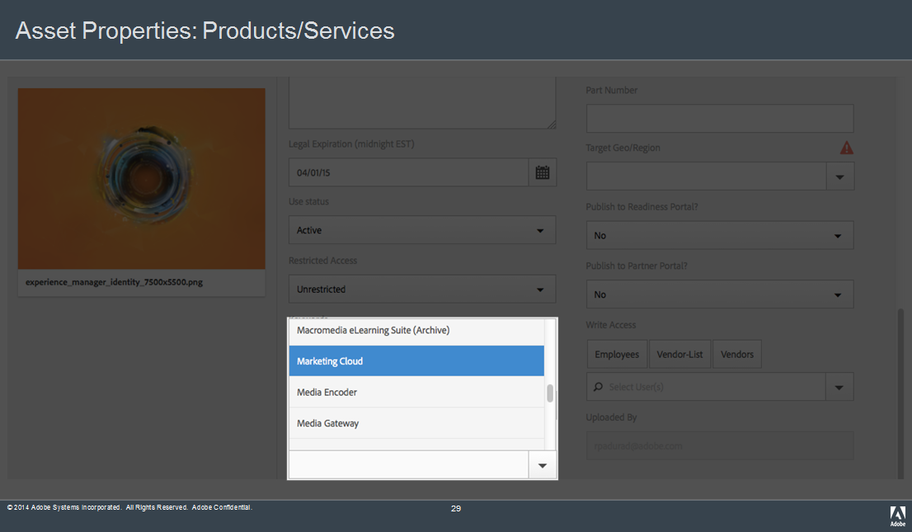

Figure 25: Metadata Field - PRODUCTS/SERVICES

1. PRODUCT VERSION: A field comprised of a list of Adobe product versions. Multiple product versions can be chosen. If no product number is applicable, choose the N/A option.

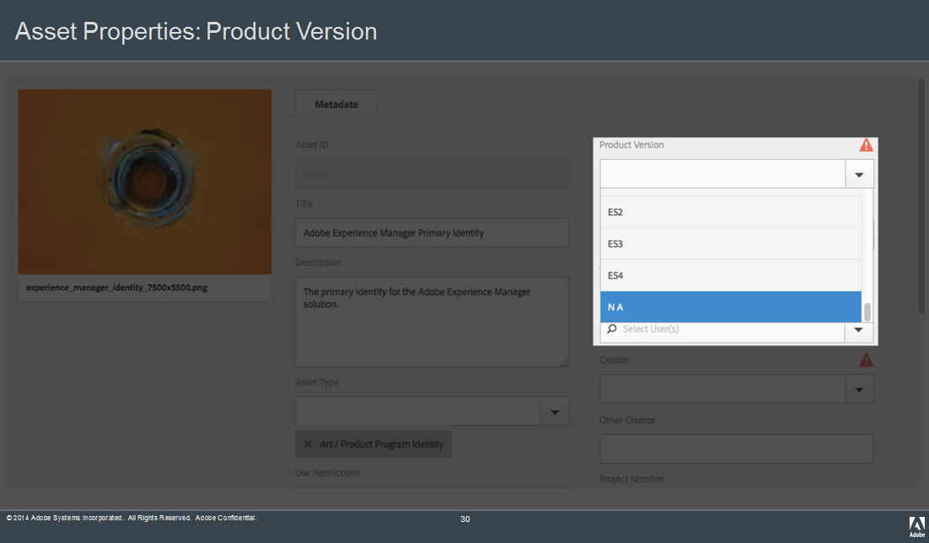

Figure 26: Metadata Field - PRODUCT VERSION

1. LANGUAGE: Select language. If the asset has no text, select N/A.

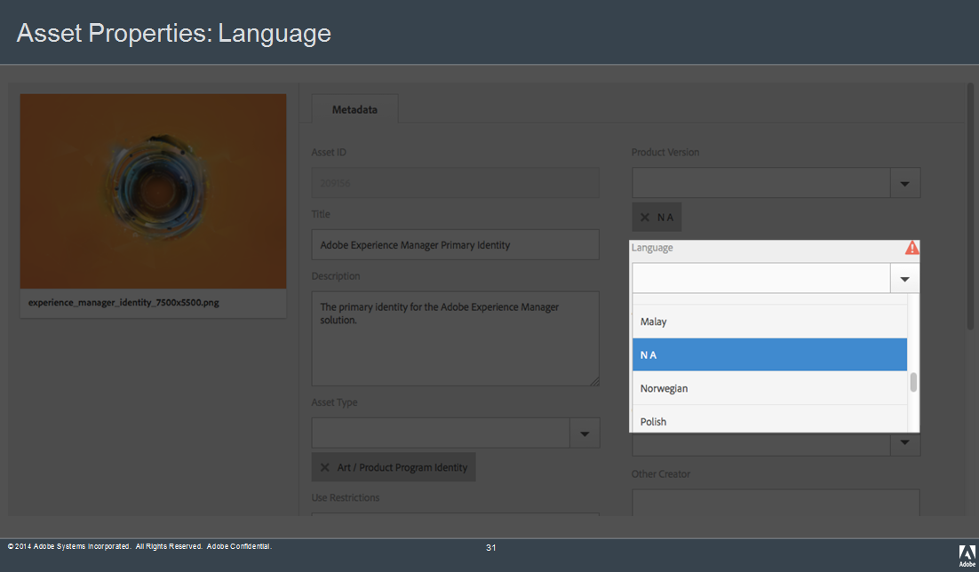

Figure 27: Metadata Field - LANGUAGE

1. ASSET OWNERS: Indicates the Adobe stakeholder who is ultimately responsible for maintaining the asset. Multiple asset owners can be specified.

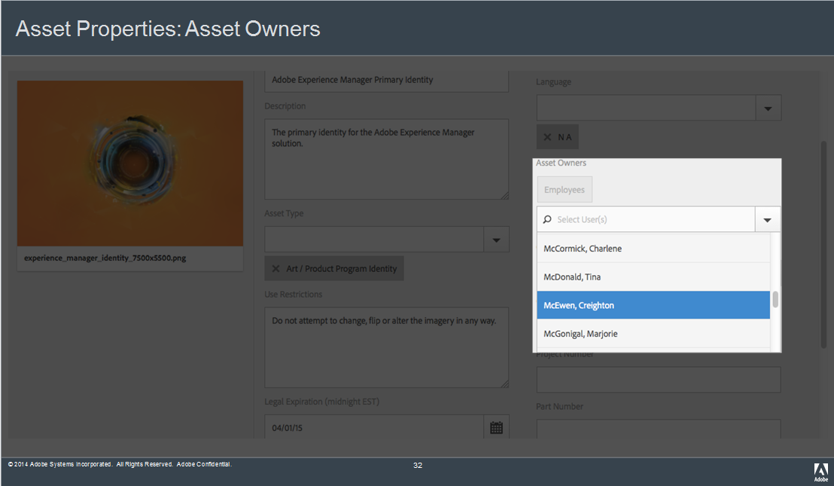

Figure 28: Metadata Field - ASSET OWNERS

1. CREATOR: The Adobe team or vendor who created the asset. Multiple creators can be specified.

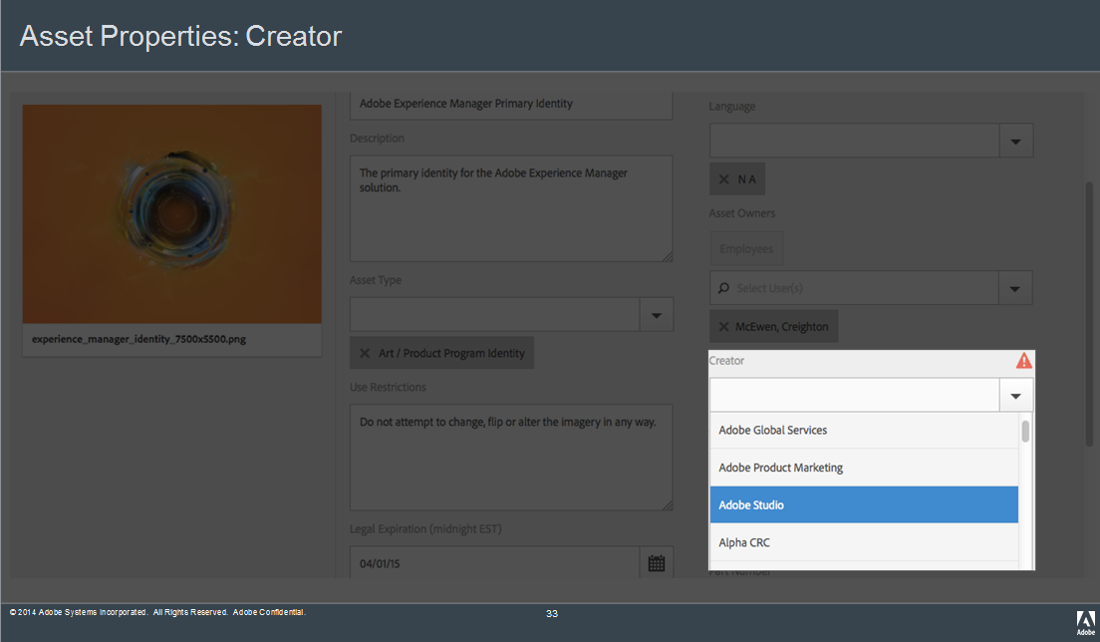

Figure 29: Metadata Field - CREATOR

1. OTHER CREATOR: When the creator of the asset is not a listed Adobe team or vendor, this field can be used to identify the creator of the asset.

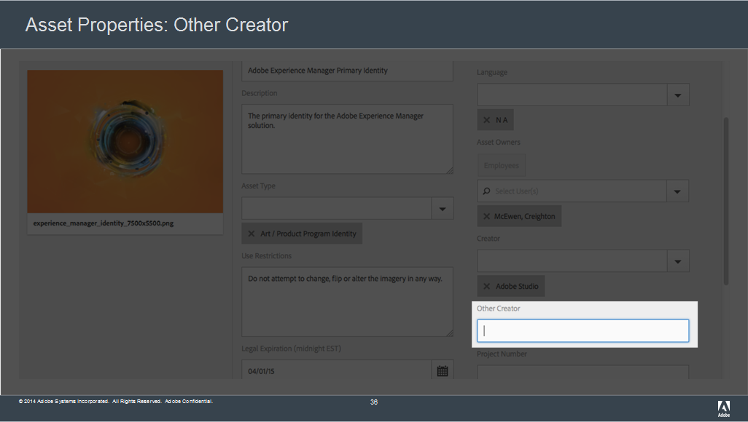

Figure 30: Metadata Field – OTHER CREATOR

1. PROJECT NUMBER: This field is used to capture Adobe project numbers associated with the asset.

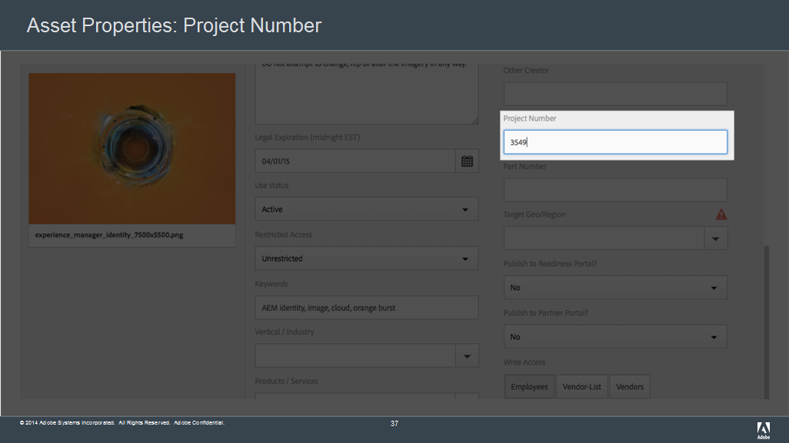

Figure 31: Metadata Field – PROJECT NUMBER

1. PART NUMBER: This field is used to capture Adobe part numbers that are associated with the asset.

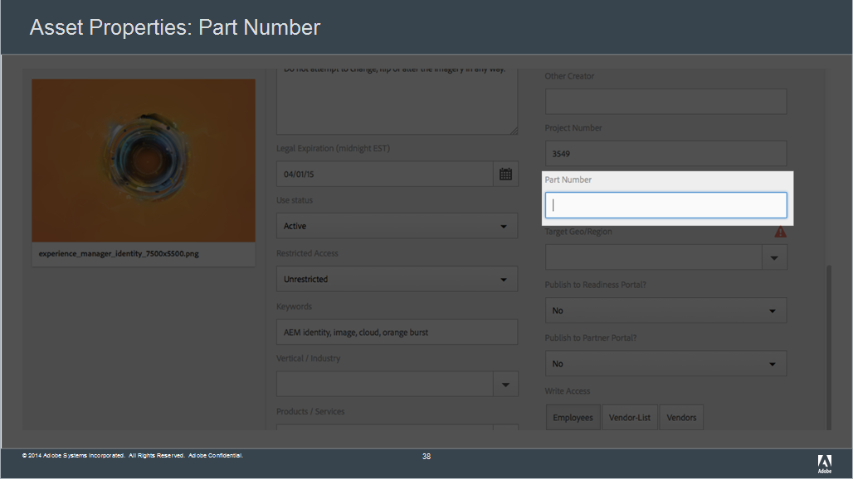

Figure 32: Metadata Field – PART NUMBER

1. TARGET GEO/REGION: For region/country use. If the asset can be used globally, select Global. If it is intended for a specific country, select the country within the region. Multiple regions/countries can be assigned to the asset.

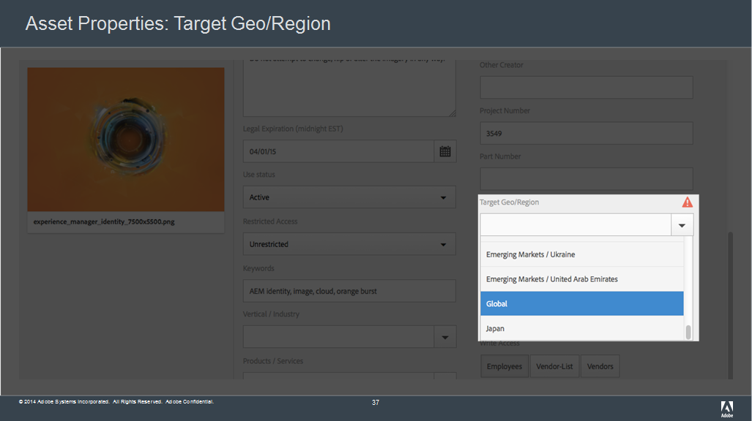

Figure 33: Metadata Field - TARGET GEO/REGION

1. PUBLISH TO READINESS PORTAL: Select Yes if asset should be published to Readiness Portal (Adobe’s internal sales enablement portal). Select No if asset should not.

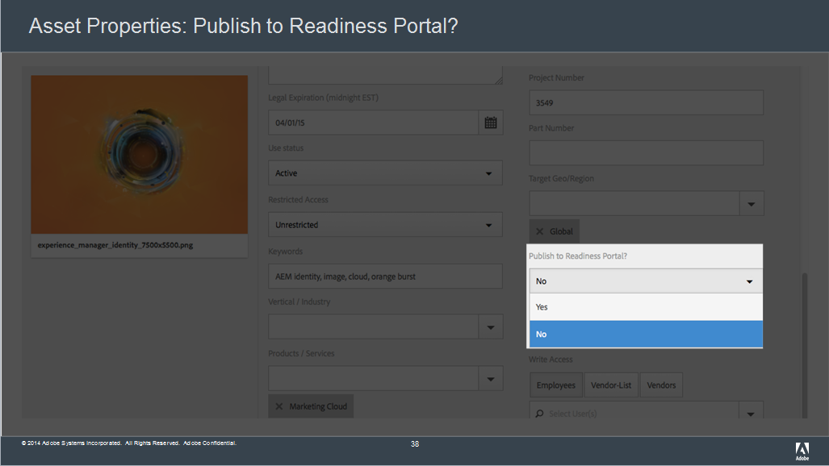

Figure 34: Metadata Field - PUBLISH TO READINESS PORTAL

1. PUBLISH TO PARTNER PORTAL: Select Yes if asset should be published to Partner Portal (an external content repository for Adobe partners). Select No if it asset should not.

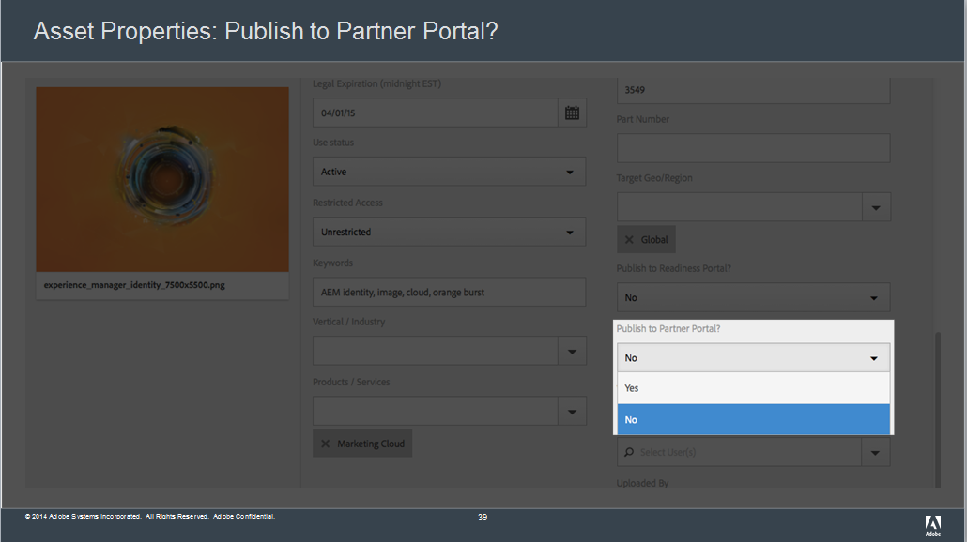

Figure 35: Metadata Field - PUBLISH TO PARTNER PORTAL

By the below matrix we can figure out whether the asset needs to publish on Infield & Partner portal, in case of confusion author needs to confirm the same with the respective asset owner.

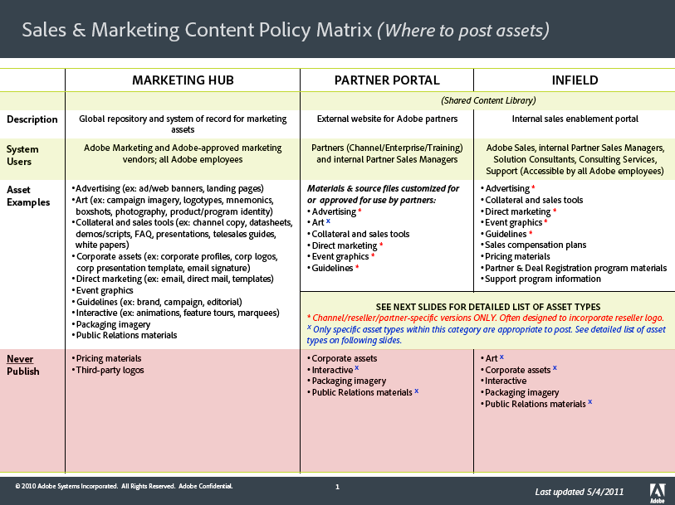

Figure 36: Sales & Marketing Content Policy Matrix

1. WRITE ACCESS: Employees or vendors specified in this list are given access permissions to change the asset. Multiple stakeholders can be given edit rights to the asset.

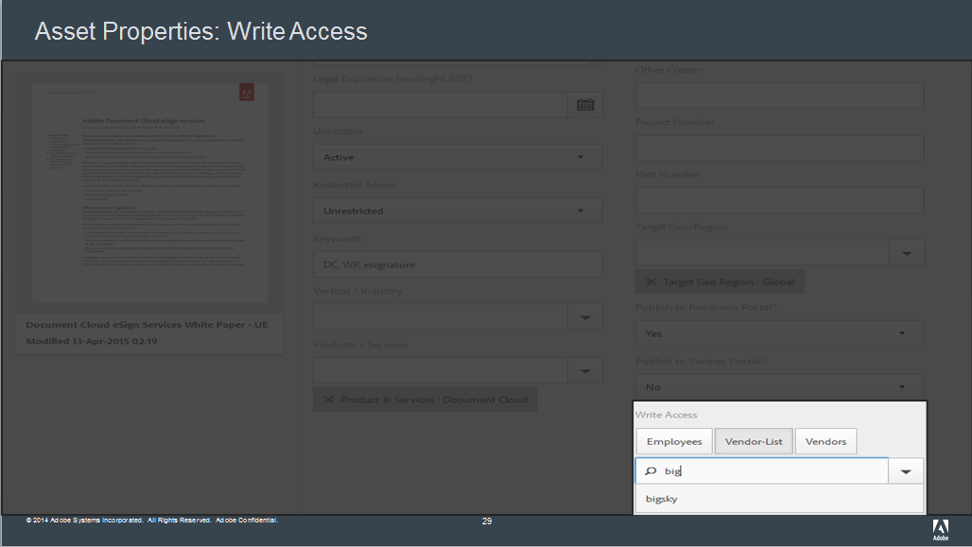

Figure 37: Metadata Field - WRITE ACCESS

1. SAVE/UPDATE: The Save button will save the asset’s metadata to the DAM repository. When you have completed filling in the appropriate metadata, click the Tick mark at the top of the page.

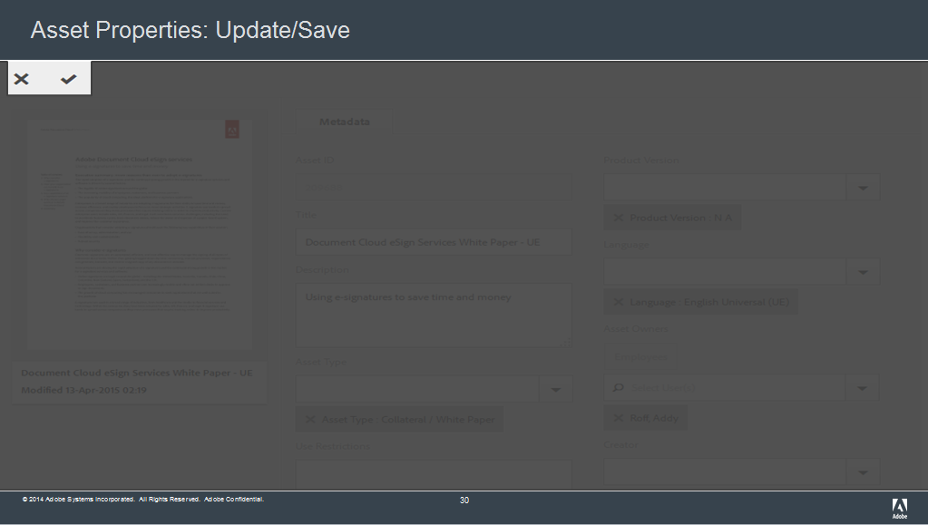

Figure 38: Metadata Field - SAVE/UPDATE

1. Close the Property page by clicking on the X on the asset tab.
2. To publish the asset, select the asset and click on the Publish button from the tool bar.

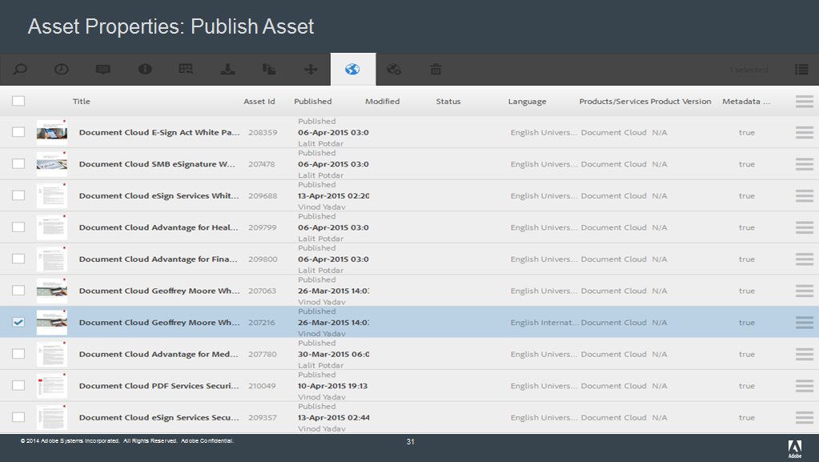

Figure 39: PUBLISH BUTTON FOR NEW ASSET

1. After uploading the assets and its rendition, share the uploaded asset ID and asset title with the requester via email.

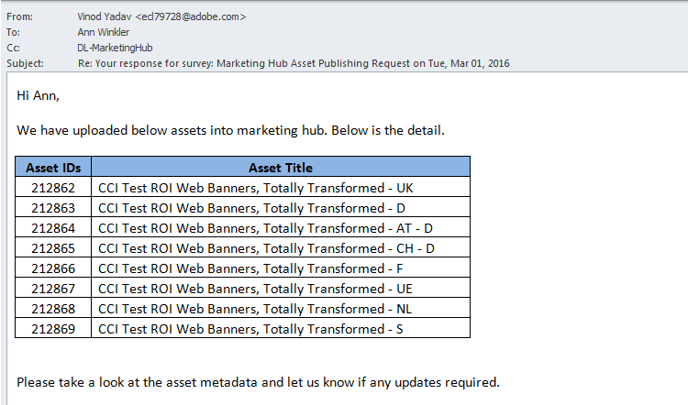

Figure 40: Send Email to Requester with asset Id and title

NOTES:

Asset activation should occur after all renditions have been added.

The asset will show “Published” in the Published column along with the publisher name and the timestamp of its activation.

Adding Rendition to an Asset

Assets added to Marketing Hub’s Digital Asset Management module have an original representation of the file that was uploaded. Quite often, it is necessary to add renditions of that asset with some changed characteristic of the original such as a different size, resolution, color model, or file type. Similarly, when the asset is undergoing a significant change, you can create a new version of the asset which creates a snapshot of the original. This creates an edit trail that gives you the ability to revert to a previous version of an asset if you need to.

Before starting, prepare the files for upload by renaming them on your hard drive. The naming convention to use for you renditions should adhere to the “Adobe’s Digital Asset Naming Guidelines“

DEFINITION:

The rendition name is the title of a specific variant of the asset. It’s the same asset, but might be different file format, size, resolution, color space, etc.

NOTES:

Use rendition name to include details such as file format, size, resolution, color space, etc.

Copy the asset title and then add rendition details to the end

The renditions are what the end user downloads for use. It is critical to think about what the end user will need when deciding on what renditions of the asset to publish.

There is no limit to the number of renditions that are included under an asset.

EXAMPLES:

Premiere Pro CS5, Workflow Guide, Final Cut Pro Editors – F – PDF

Flash Professional CS6 Affiliate Web Banner - F - 300x250 – PSD

Adobe & Security Print Ad - UE - High Res PDF

1. Click on the asset to open the asset detail page. Click the rendition icon to display the rendition pane.

Note: The following picture shows the asset details page. The Renditions icon is outlined in red.



Figure 44: ASSET DETAIL PAGE

1. The following picture shows the asset details page with the Renditions panel displayed. Only the original rendition, which is generated by the system when the asset is created, is listed



Figure 45: RENDITIONS PANEL

1. On the rendition tab on the right-hand side of the screen, you will see the original representation of the uploaded asset. You can add a rendition two different ways:
2. Click the Upload Rendition icon in the Toolbar to upload a new rendition for the asset.



Figure 46: UPLOAD RENDITION ICON

1. A pop-up window will display asking you to browse to the file(s) that you wish to upload. To select multiple files, press and hold the Cmd or Ctrl key and select assets in the file picker dialog window.

Note: Or drag the rendition file(s) from your computer directly into the rendition area above the original.

NOTE:

Be sure to highlight and edit the Title of the rendition if you dragged and dropped the renditions by double clicking on the rendition.

Rendition files that are downloaded keep the file name they were given when published. A descriptive file name, similar to the rendition name, will ensure that the end user knows at a glance what the file is once the save it on their computer.

Do not include special characters in the file name. Asset renditions with special characters in the file names cannot be downloaded successfully.

When you add your first asset rendition, be sure that it is a file type that will generate a thumbnail in the system. A .pdf or .jpg is recommended formats to load when the asset file type does not generate a thumbnail.

Additional renditions may be added after you have saved the asset with the first rendition.

Renditions that are high resolution can be indicated after you have added them.

1. Double click on a rendition listed in the Renditions pane to open the Edit Title window. Following the Marketing Hub’s rendition title guidelines, enter the proper Rendition Title and click Save



Figure 47: EDIT RENDITION TITLE

Adding New Version of Asset

A version is a revision of an asset. If an asset is modified or changed in any way a new version can be posted that will sit “on top” of the previous version(s). Possible reasons for a new version are:

Asset must be updated due to new trademark requirements.

Collateral is updated due to change in system requirements.

1. Click on the version icon to display the version panel.

The following picture shows the asset details page. The Versions icon is outlined in red



Figure 48: NEW VERSION ICON

1. In the version panel, view the list of versions for the asset

The following picture shows the asset details page with the Versions panel displayed. No versions are listed in the panel because the asset has never been versioned.

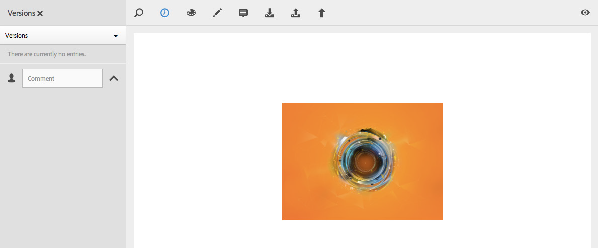

Figure 49: VERSION PANEL

1. STEP 58. Click the Actions icon and click Save as Version to initiate the creation of a new version

The following picture shows the Save as Version button, which appears after clicking the Actions icon. The Actions icon is outlined in red.

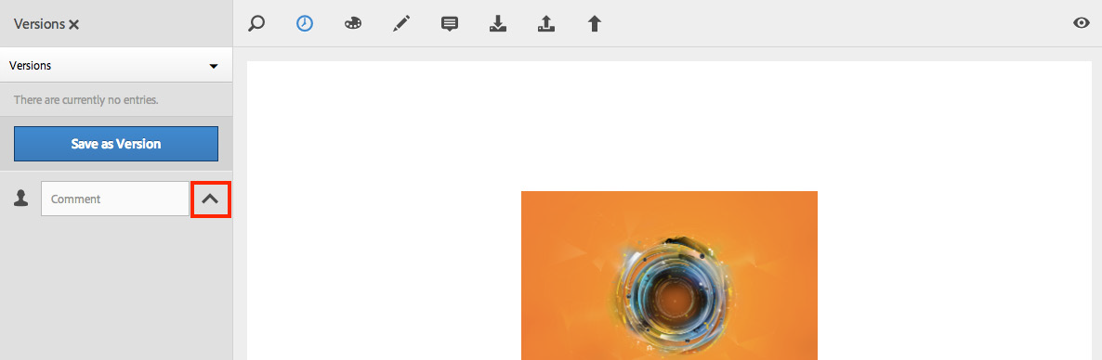

Figure 50: ACTION ICON

1. Click the upload file icon and select the new version file.

The following picture shows the File upload icon outlined in red. The Create button activates after a file is selected to replace the original asset rendition.



Figure 51: UPLOAD FILE ICON

1. Add a Version label and/or Comment (optional)

NOTE:

The rendition uploaded must be one that renders thumbnails, as new thumbnails will be rendered.

Values entered in the Version Label and the Comment fields should refer to the version being archived NOT the new version being uploaded.

Make sure your label and comments accurately describe the version in case there is a need to restore that particular version in the future

1. Click Create to confirm the action and create a version for the asset

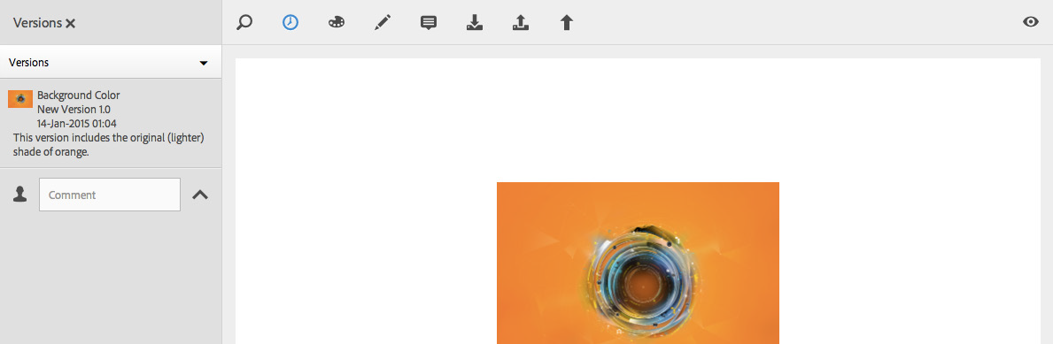

Figure 52: NEW VERSION CREATED

1. Upload new renditions and/or change any relevant metadata for the new version.
2. Re-publish the asset.

Revert Version – Revert back to old version from newly created version.

1. Select a version from the list and click Revert to this Version to revert to the version selected.



Figure 53: NEW VERSION CREATED

1. Re-publish the asset so the reverted version is what users view and download on Asset Finder.

Bulk Upload: The bulk metadata editor enables asset publishers to simultaneously edit common properties of multiple assets. Use of the editor saves time and helps ensure metadata consistency. While the editor can be used for updating any group of assets, it’s most helpful when editing the properties for a collection of localized assets or like assets for a specific campaign program or product launch.

STEP 64. Locate the assets you want to edit by navigating to the folder the assets are stored or by searching for the assets.

1. Select the assets for which you want to edit common properties
2. Click the Properties icon to open the Bulk Metadata editor for the selected assets.



Figure 54: BULK UPDATE

1. Populate the metadata that you want to apply to all assets being edited.
2. Click the Update icon to save the changes.

This picture shows the Bulk Metadata editor. The Update icon is outline in red.



Figure 55: BULK METADATA EDITOR

1. Click the OK button to complete the modifications.

The following picture shows the Asset(s) modified window. Click OK to complete the bulk update.

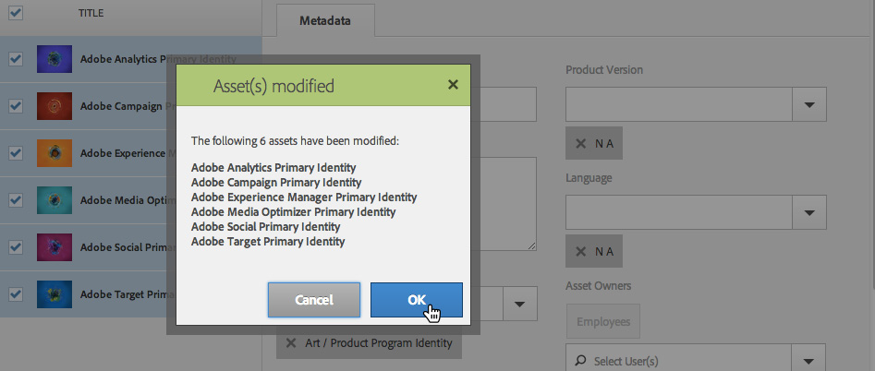

Figure 56: BULK ASSETS MODIFIED WINDOW

1. To view the metadata editor for a specific asset in the list, clear the checkboxes corresponding to the remaining assets. The metadata editor fields for the particular asset are populated with the previously-added metadata for the asset.

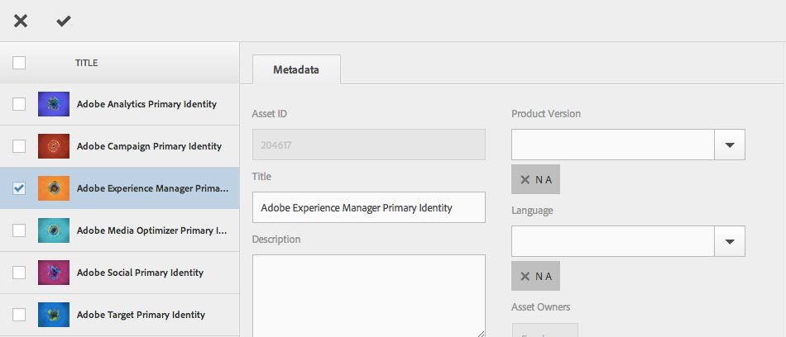

Figure 57: BULK ASSETS MODIFIED WINDOW

Note:

Select the checkbox adjacent to Title to toggle between selecting all the assets and clearing the list.

Revert Bulk Upload: Undo the bulk upload

1. STEP 71. If an error was made, click the Revert icon to undo bulk changes.

This picture shows the Revert icon, which appears after completing a bulk update.



Figure 58: REVERT ICON

1. Click OK to complete the reversal.

This picture shows the Asset(s) Reverted window. Click OK to complete the reversal.



Figure 59: REVERT WINDOW

MARKETING HUB Reference

Approved Marketing Hub Language Abbreviations

Below is a list of approved language abbreviations for use in marketing hub digital asset titles and rendition names. Any common language abbreviations other than what is listed should not be used.

|  |  |  |  |
| --- | --- | --- | --- |
| **Language.** | **Abbreviation.** | **Language** | **Abbreviation** |
| Arabic | AR | Japanese | JP |
| Bulgarian | BG | Korean | KR |
| Catalan | CA-ES | Latin America Spanish | LA |
| Chinese Simplified | CS | Latvian | LV |
| Chinese Traditional | CT | Lithuanian | LT |
| Croatian | HR | Norwegian | NO |
| Czech | CZ | Polish | PL |
| Danish | DK | Portuguese | PT |
| Dutch | NL | Portuguese Brazilian | BR |
| English British | UK | Romanian | RO |
| English International | IE | Russian | RU |
| English Universal | UE | Serbian | RS |
| Estonian | EE | Slovakian | SK |
| Finnish | FI | Slovenian | SI |
| French | FR | Spanish | ES |
| French Canadian | FC | Swedish | SE |
| German | DE | Thai | TH |
| Greek | GR | Turkish | TR |
| Hebrew | HE | Ukrainian | UA |
| Hungarian | HU |  |  |
| Italian | IT |  |  |

**Table 3: Marketing Hub Language Abbreviations**

A list of all the country abbreviations for the approved vendor’s spreadsheet.

<https://laendercode.net/en/2-letter-list.html>

NOTES:

English Universal: US English; asset is used in North America; 8.5x11 paper size

English International: US English with North America specific aspects removed; asset is used in APAC, EMEA, or Japan; A4 paper size

English British: UK English with North America specific aspects removed; asset is used in APAC, EMEA, or Japan; A4 paper size

MARKETING HUB Reference

File Formats that Render Thumbnails

A Marketing Hub thumbnail is a representation of an image or a document to help you identify a digital asset. The thumbnail that appears is either an auto-generated image rendered from the digital asset’s current version or a custom thumbnail image loaded by an Asset Publisher.

The application automatically renders thumbnails for the file formats listed below. For unsupported file formats, a generic icon is shown.

For a complete list of file formats that can be stored in the Marketing Hub, refer here.

|  |  |
| --- | --- |
| File Format | Extension(s) |
| Audio Video Interleave | .avi |
| Flash Video | .flv |
| Graphical Interchange Format | .gif |
| JPEG Image | .jpeg |
| iTunes Video | .m4v |
| MPEG-4 | .mp4 |
| QuickTime Movie | .mov |
| Portable Document Format | .pdf |
| Portable Network Graphic | .png |
| PowerPoint Presentation | .ppt, .pptx |
| Photoshop Document | .psd |
| Tagged Image File Format | .tiff |

**Table 4: File Formats**

### How to create a New Folder

1. Navigate to the DAM Admin page.

Note: Any new folder is created as per the Adobe standard taxonomy sheet

1. Navigate to the location in the folder tree where you want to create a new folder.

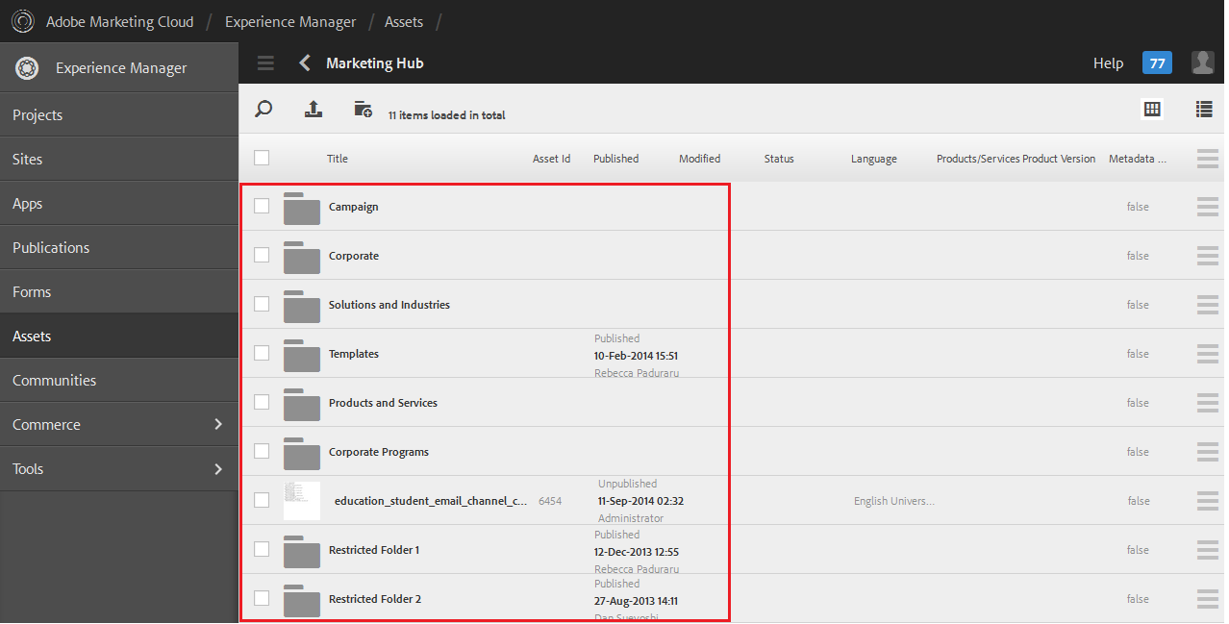

Figure 60: Folder Tree

1. Click on Create Folder Icon



1. In the Title field, type the name of the folder Name field will auto populate.

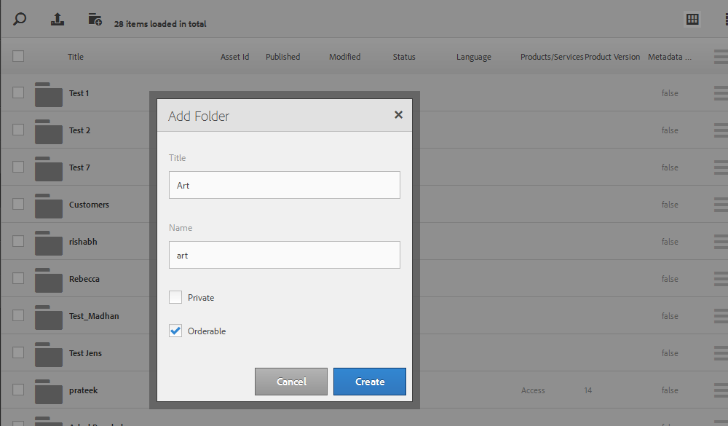

Figure 61: Folder Name and Title

1. Click Create.

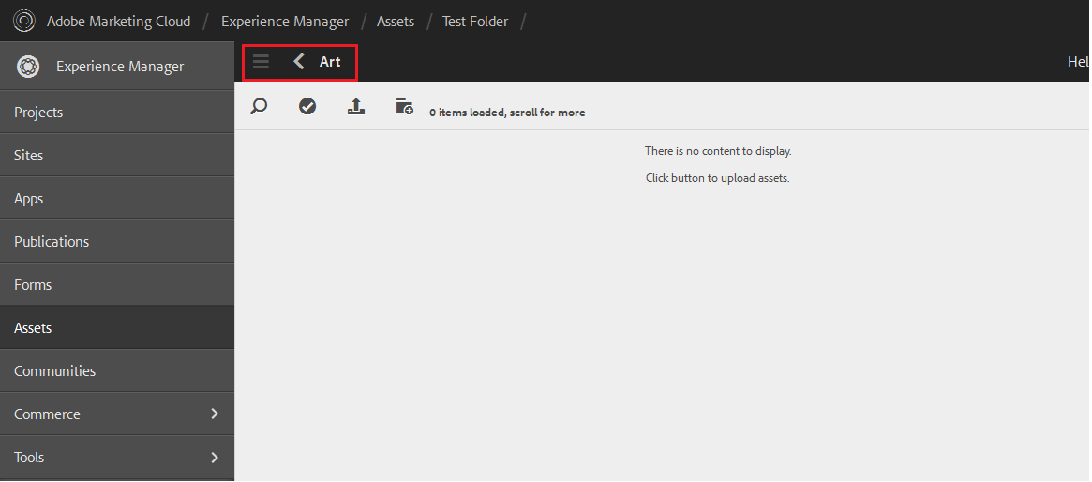

Figure 62: New Folder Page

NOTES:

* The name that appears in the Name field will appear in the URL, e.g. “myfolder”
* The name that appears in the Title field will appear in the folder tree, e.g. “My Folder”

Create a New Metadata Template (eClerx doesn’t create template until asked by Adobe’s POC)

**Create a New Metadata Profile**

1. In the Rail, click Tools > Assets > Processing Profiles.

2. Click Metadata Profiles.

3. Select a “master” processing profile template and then click the Copy icon.

4. Enter a title for the new metadata profile and click Copy.

5. Locate and select the newly created template.

6. Select the Edit icon.

7. Click the field that you want to populate. On the Settings tab, populate the Default Value with the desired text or tag. Repeat for all applicable fields

8. Click Done.

NOTE:

If you click Cancel, the metadata template will not save.

**Create a Processing Profile**

1. In the Rail, click Tools > Assets > Processing Profiles.

2. Click Overview.

3. Click the Add Processing Profile icon.

4. In the Add Profile box, enter a title for your processing profile and click Submit.

5. On the Details tab, review the Name and enter a Description.

6. Click the Metadata tab. In the Template tag field, select the proper metadata profile.

7. Click Done.

**Applying a Processing Profile to a Folder**

1. Select the Processing Profile and click the Apply to Folder icon.

2. Navigate to the location that the folder you want to apply the processing profile lives (Do not click on the folder you want to apply the processing profile to)

3. Click the Select icon.

4. Select the folder

5. Click Done

## Interlinks within eClerx processes

* None as of now

## Output

### What is the Output?

* Uploaded Assets in Marketing Hub

### Whom is it sent to?

* Requester (vendor) by looping Adobe stakeholder if requester is vendor
* Adobe Stakeholder

### Where is the Output Saved?

* In Marketing Hub

## Checklist

|  |  |
| --- | --- |
| **Field Name** | **Field Description** |
| **Asset File Name** | Have you updated the asset file name as per the Adobe naming guidelines? |
| **Rendition File name** | Have you updated the rendition file name as per the Adobe naming guidelines? |
| **Asset Title** | Have you added the asset title as per the Adobe naming guidelines? |
| **Asset Description** | Did you add the asset description, if provided by the requestor? |
| **Asset Type** | Have you added the asset type following the Adobe folder taxonomy? |
| **Use Restrictions** | Have you added the use restriction, if provided by the requestor? |
| **Legal Expiration** | Did you add the legal expiration date, if provided by the requestor? |
| **Use Status** | Check if the use status is active. By Default active. |
| **Restricted Access** | Check if the restricted access is “Unrestricted”, until and unless specified by the requestor. |
| **Keywords** | Have you added the keywords? |
| **Vertical / Industry** | Have you added the vertical / industry name, if provided by the requestor? |
| **Products / Services** | Have you added the products / services? |
| **Product Version** | Have you added the product version? |
| **Language** | Have you added the language, as provided by the requestor? |
| **Asset Owners** | Have you added the asset owners, as provided by the requestor? |
| **Creator** | Have you added the creator, as provided by the requestor? |
| **Other Creator** | Have you added other creator, in case the requestor provides the creator, other than Adobe list? |
| **Project Number** | Have you added project number, if provided by the requestor? |
| **Part Number** | Have you added part number, if provided by the requestor? |
| **Target Geo/Region** | Have you added geo/region, as provided by the requestor? |
| **Publish to Readiness Portal?** | Have you updated publish to readiness portal, as per the requestor? |
| **Publish to Partner Portal?** | Have you updated publish to partner portal, as per the requestor? |
| **Rendition** | Have you uploaded the rendition, if provided by the requestor? |

Table 5: Asset Upload Checklist

# New Account Creation in Adobe Marketing Hub

## Introduction

Fundamentally eClerx needs to create an account in Marketing Hub for a vendor which comes under employee type 5 categories.

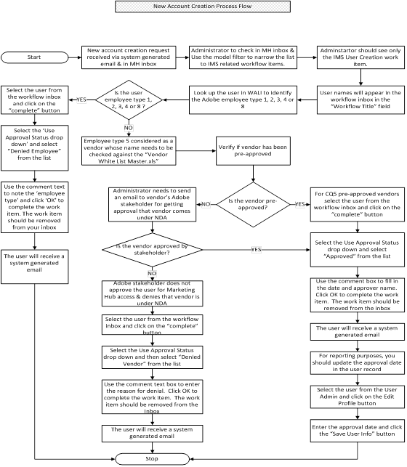

Figure 63: New Account Creation Process Flow

## Process Tools

* CQ5 DAM

## Input

### Input Documents

* New account creation request details in Marketing Hub’s inbox

### Sender of Input Documents

* Requestor
* Rebecca Paduraru

### Location of Input Documents

* Outlook & CQ5 DAM inbox

### Naming Convention of Input Documents

* NA

## Procedure

1. Vendor user provisioning: System admin email and inbox filtering.
2. When a new vendor user logs into the Marketing Hub, the administrators will receive a system generated notification similar to this. The sections to the email are:
   1. Date and time the work item was created, the recipient admin (i.e. you) and the workflow type (e.g. IMS “vendor” user).
   2. Link to the work item payload. As FYI: this will show the technical details regarding the item. You need to be logged into the system to access this link.
   3. Link to the work item inbox. This link will also indicate if this request came from development (a-daylightdev.adobecqms.net),stage(a-daylightstage.adobecqms.com) or production (a-marketinghub.adobe.com).

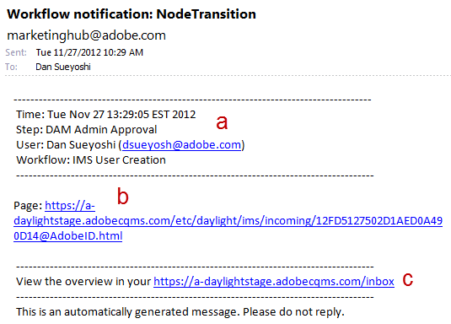

Figure 64: Workflow Notification

Workflow Inbox (production):<https://a-marketinghub.adobe.com/inbox>

The workflow inbox can also be reached through the welcome screen link.

a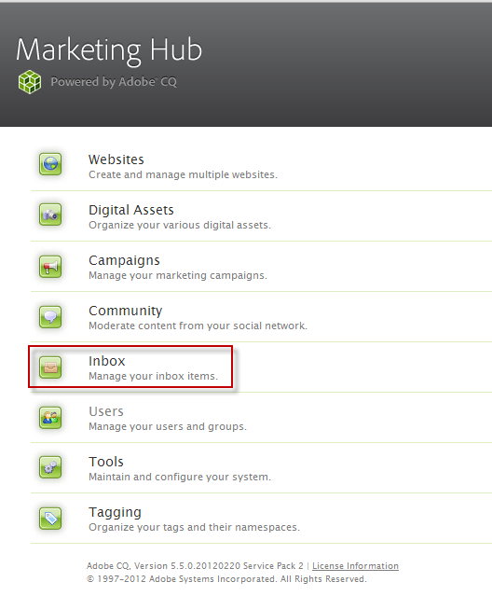

Figure 65: Marketing Hub

1. This will show a list of all workflows in progress. Use the model filter to narrow the list to IMS related workflow items.

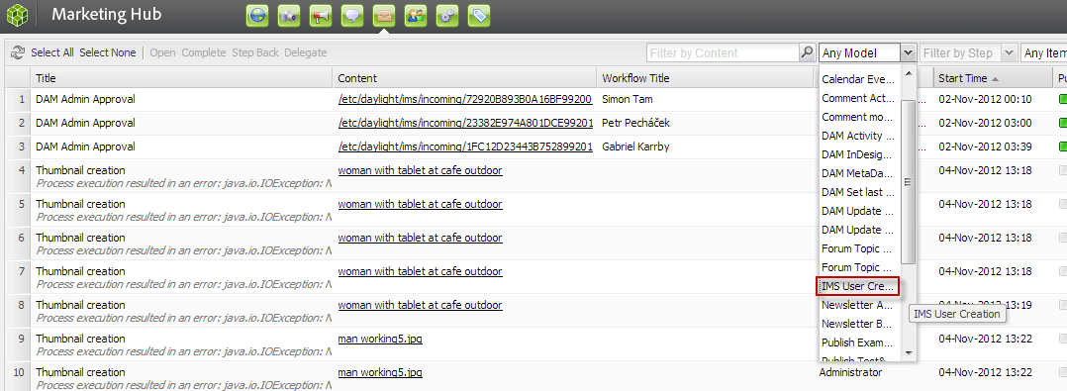

Figure 66: Model Filter

1. You should see only the IMS User Creation work items.

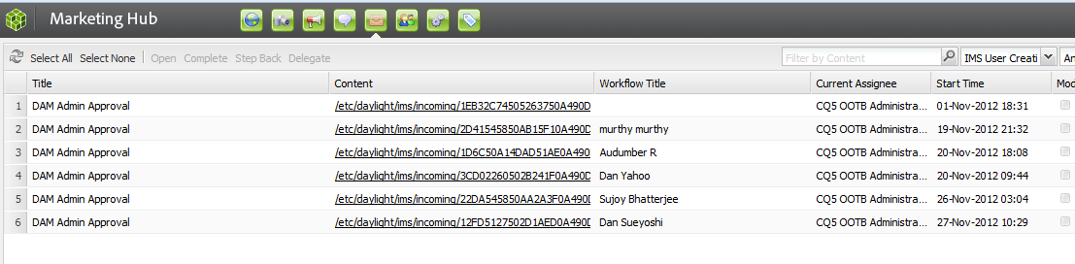

Figure 67: IMS User Creation

1. Vendor user provisioning: Verifying approval to use the Adobe Marketing Hub
2. User names will appear in the workflow inbox in the “Workflow Title” field.

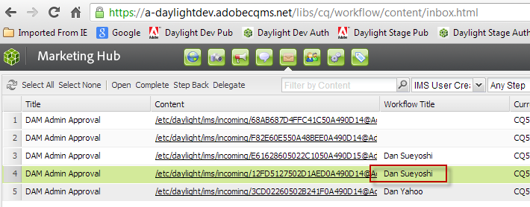

Figure 68: Workflow Title

1. Look up the user in Adobe HUB – Employee Directory to verify that they’re not an employee type 1, 2, 3, 4 or 8. Users of those types should be access through the “employee login” link rather than the “vendor login” link. Employee type 5 (Vendor) and S (Badge Only access) should use “vendor login”.

**Type S: Badge Only Access (Consultants, MSP/OSG workers, receptionists/operators)**

These workers are not given any system access, email, and phone or directory listings. Prior to receiving badge access, the consultant/vendor must have a signed contract and NDA on file with Adobe. Adobe contact will need to verify their status every 90 days.

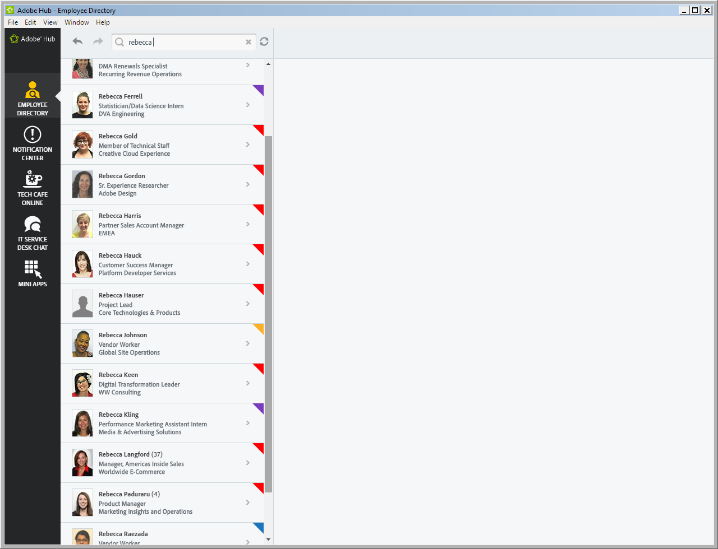

Figure 69: Adobe Hub – Employee Directory

1. If they have not been pre-approved, you will need to send an email to their Adobe stakeholder – listed as “Approved By” in the workflow payload or profile information. To access this information, click on the content link.

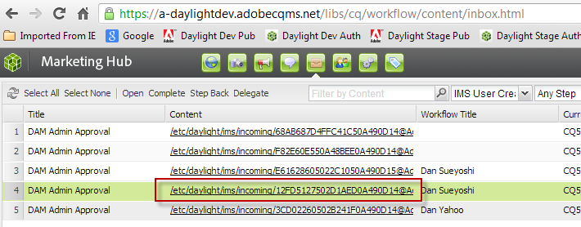

Figure 70: Approved By Details link

You are looking for the company and approved By properties.

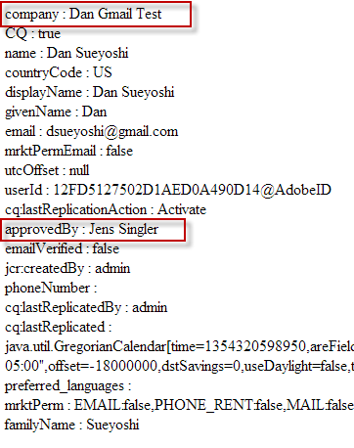

Figure 71: Approved By

With this information, you can send the approver the canned email request. Here is an example for the above workflow item.

Subject:

Adobe Marketing Hub Access Request: Dan Sueyoshi, Dan Gmail Test

Body:

Hi Jens,

We received a request from Dan Sueyoshi of Dan Gmail Test for access to the Marketing Hub. The site is only available externally to Adobe-approved marketing/design vendors (under NDA), who are working on an Adobe project for an internal team. Would you confirm that this is one of your vendors and they meet those requirements? Once we have your approval, we will follow the appropriate steps to create a new account in the Marketing Hub.

Please note that Marketing Hub is not available to vendors still going through the approval process or partners, resellers/distributors, user groups, customers, or press - they should be directed to the appropriate partner site or press room.

Regards,

User Administration

Adobe Marketing Hub

1. Vendor user provisioning: Case 1 – vendor users who are approved for access
2. If the user has been pre-approved or the Adobe stakeholder has replied with approval, select the user from the workflow inbox and click on the “complete” button.

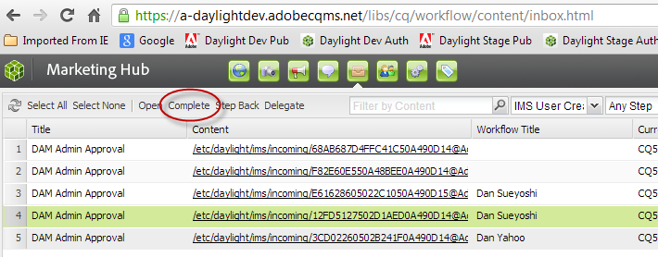

Figure 72: Complete Button

1. This will open the work item dialog. Select the Use Approval Status drop down and select “Approved” from the list.

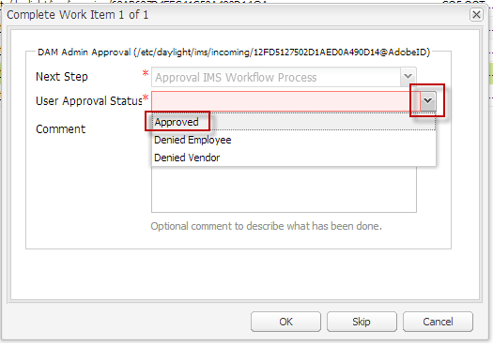

Figure 73: User Approval Status

1. Use the comment box to fill in the date and approver name. Click OK to complete the work item. The work item should be removed from the inbox.

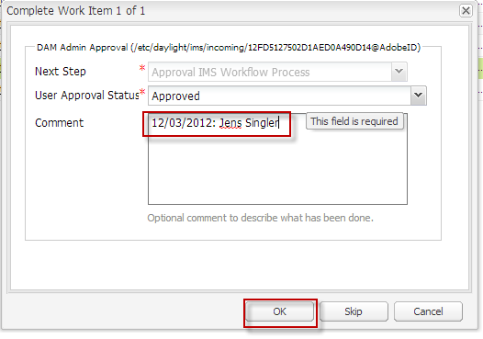

Figure 74: Comment and Ok Button

1. The user will receive the following system generated email.

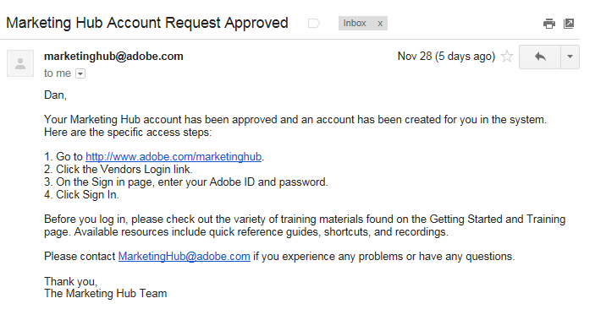

Figure 75: Auto generated Mail

1. For reporting purposes, you should update the approval date in the user record. To access the profile, select the user from the User Admin and click on the Edit Profile button.

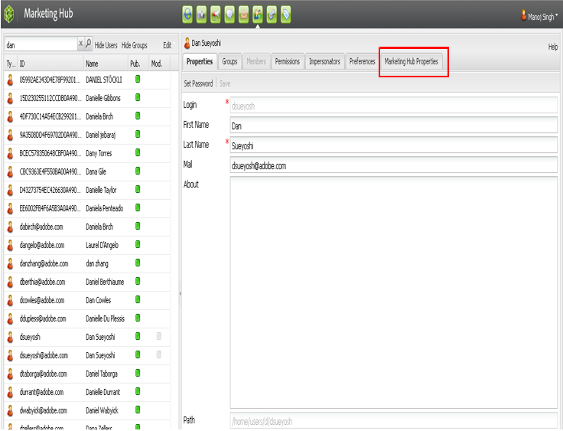

Figure 76: Edits Profile Button

1. Enter the approval date and click the “Save User Info” button.

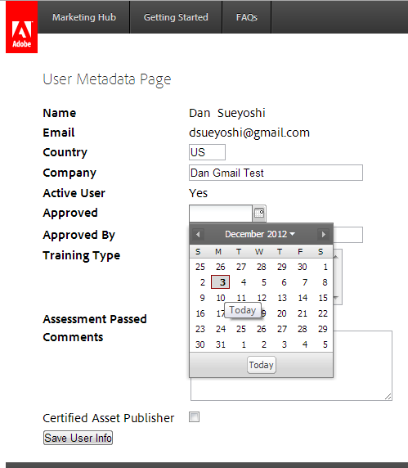

Figure 77: Save User Info Button

Vendor user provisioning: Case 2 – vendor users who are denied access

1. If the Adobe stakeholder does not approve the user for Marketing Hub access (e.g. user should be using the Adobe Partner Portal instead), select “Denied Vendor” from the User Approval Status drop down list.

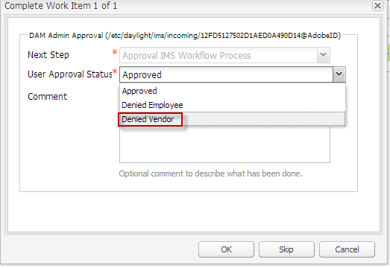

Figure 78: User Approval Status

1. Use the comment text box to enter the reason for denial. Click OK to complete the work item. The work item should be removed from the inbox.

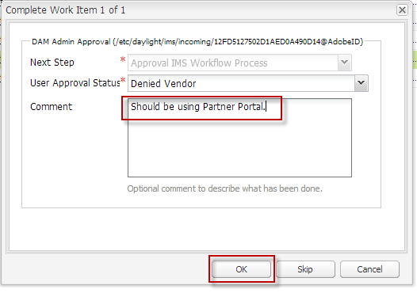

Figure 79: Comment & Ok Button

1. The user will receive the following system generated email.

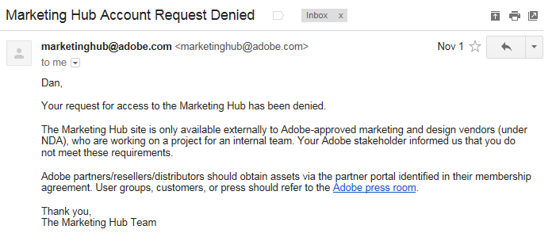

Figure 80: Auto generated mail

Vendor user provisioning: Case 3 – employee users

1. Employee users (users of employee type 1, 2, 3, 4 or 8) should be accessing the Adobe Marketing Hub via the “employee login”. Select “Denied Employee” from the User Approval Status dropdown list.

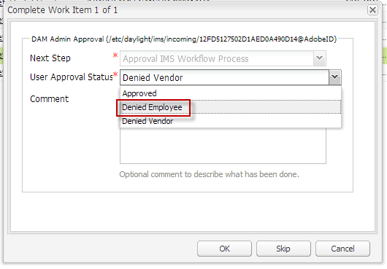

Figure 81: User Approval Status

1. Use the comment text to note the employee type and click OK to complete the work item. The work item should be removed from your inbox.

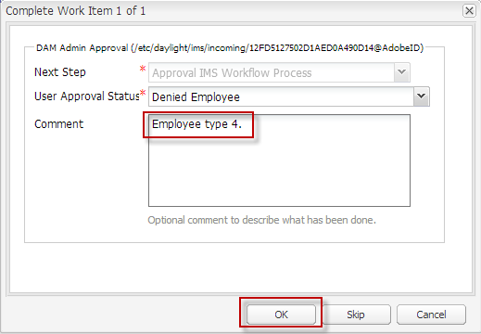

Figure 82: Comment & Ok button

1. The user will receive the following system generated email.

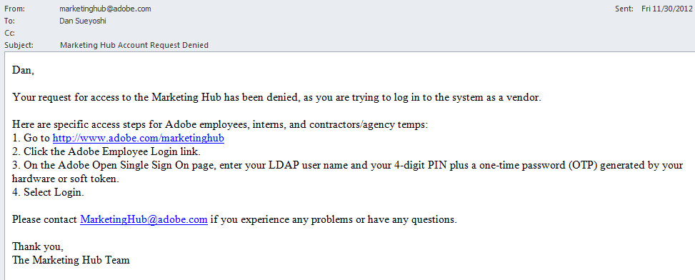

Figure 83: Auto Generated Mail

Note: While asset publishing if you could not find the asset owner’s name (Adobe Employee) in the metadata field, then you might need to create an asset owner’s account

Creating Asset Owners account

There are two ways for the user to show up in the owner field. To manually create the account or to ask the employee to log in. Asking the user to log in is the best method so that way we don’t make any mistakes. However, here are the steps for creating a new employee user:

1. Click Users
2. Click Edit, point to Create and click Create User

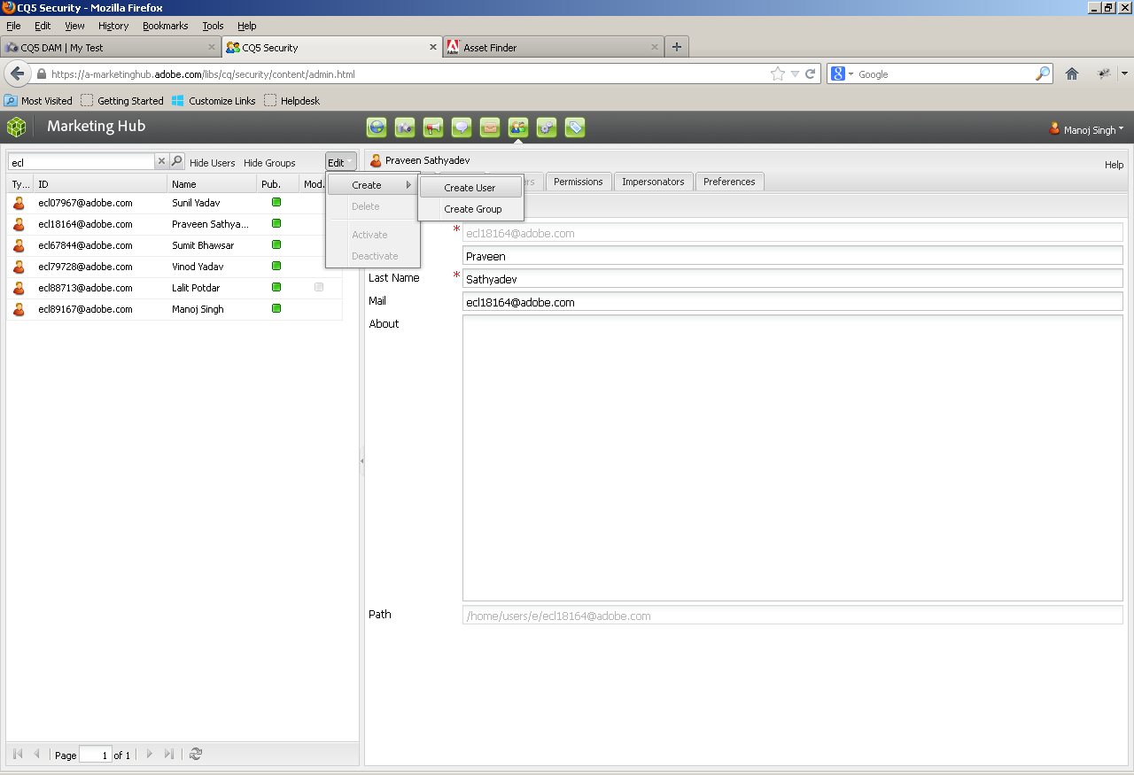

Figure 84: New User

1. In Login ID, enter the employees full email address

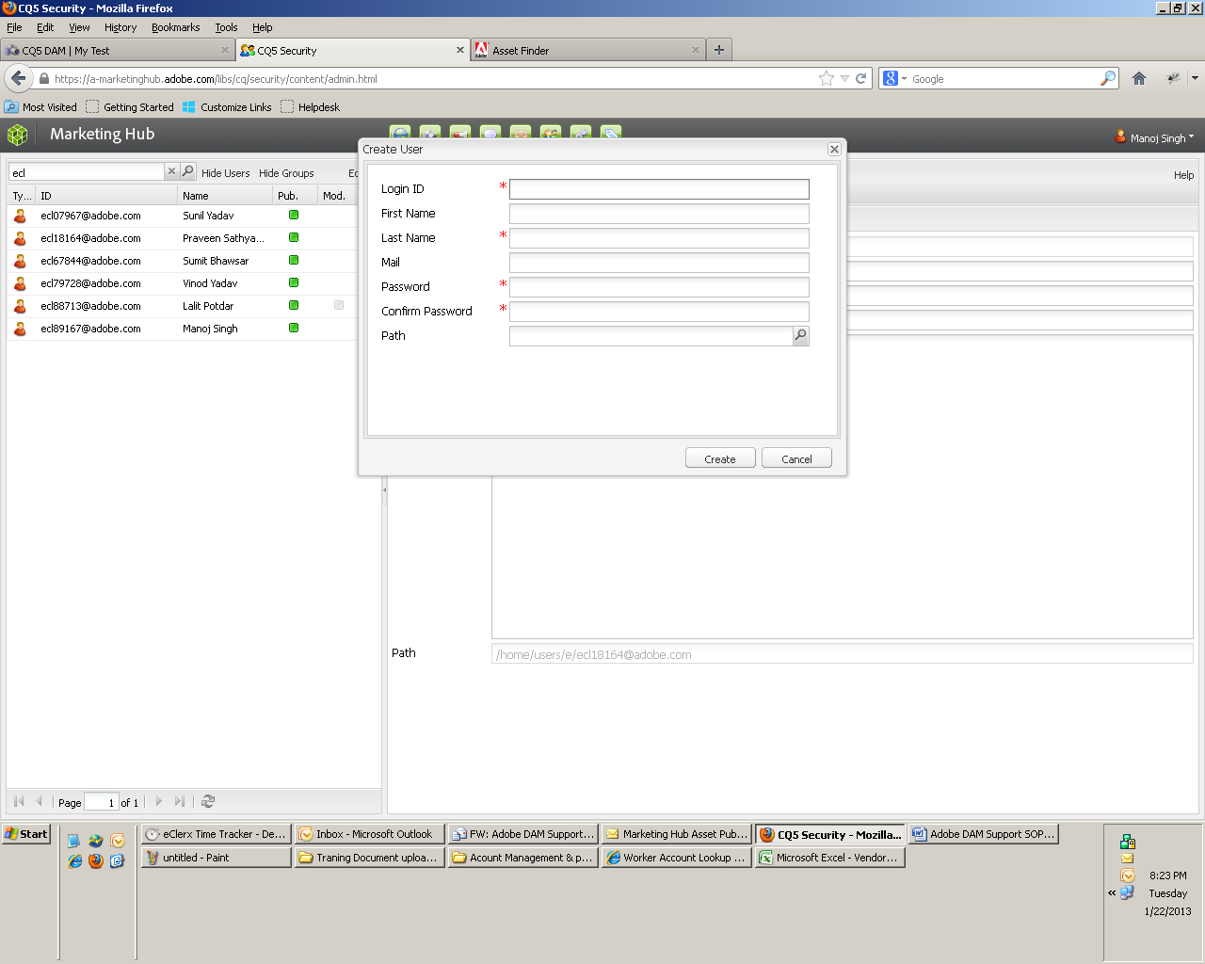

Figure 85: Login ID

1. In First Name, enter the users first name
2. In Last Name, enter the users last name
3. In Mail, enter the employees full email address
4. In Password and Confirm password, enter a generic system password. Please use ‘changeme’
5. For path, click the magnifying glass icon and select the letter of their last name and click ok
6. Click create
7. Find the user, and click on the Groups tab
8. Filter the user groups and add, Marketing Hub Employees

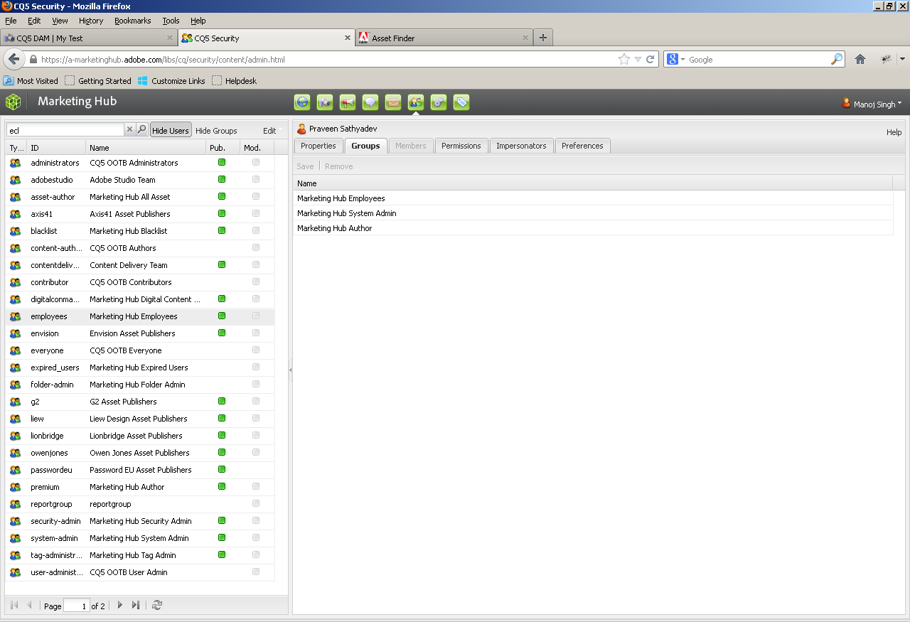

Figure 86: User Group

1. Re-activate the Marketing Hub Employees group by dragging/adding it in the users account group

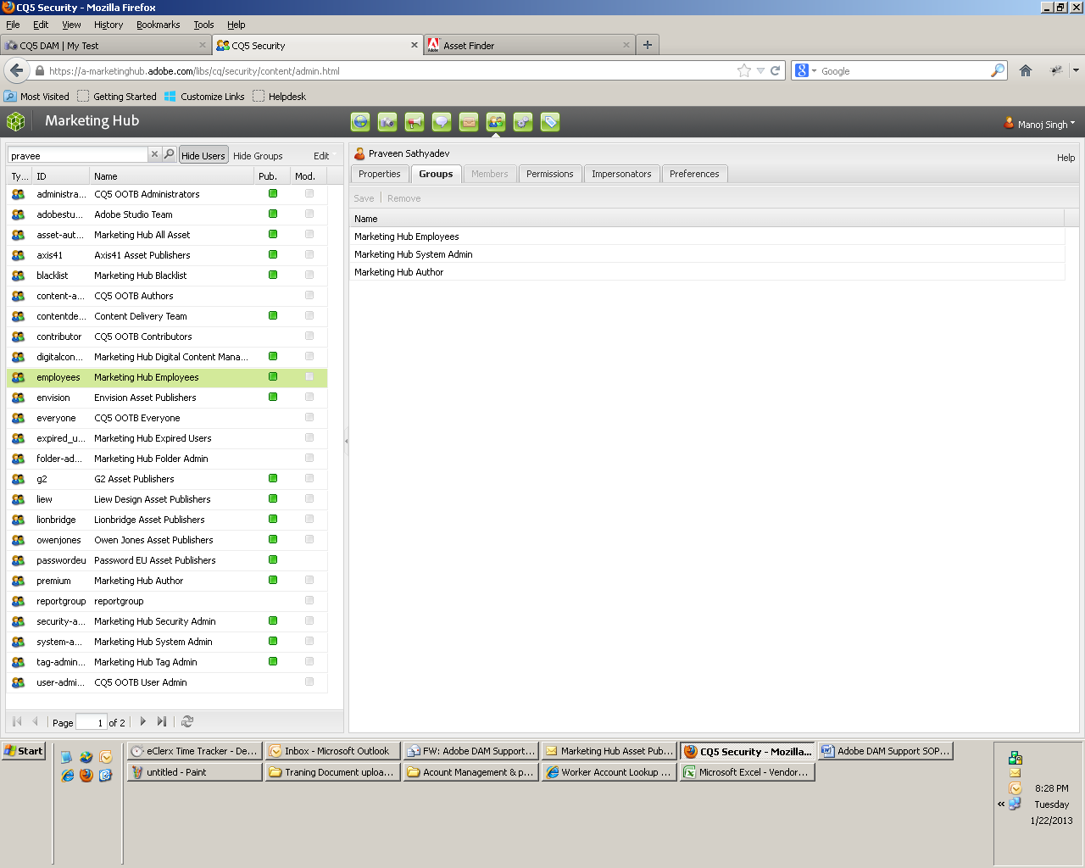

Figure 87: Re-activation

1. Filter the user and activate the user

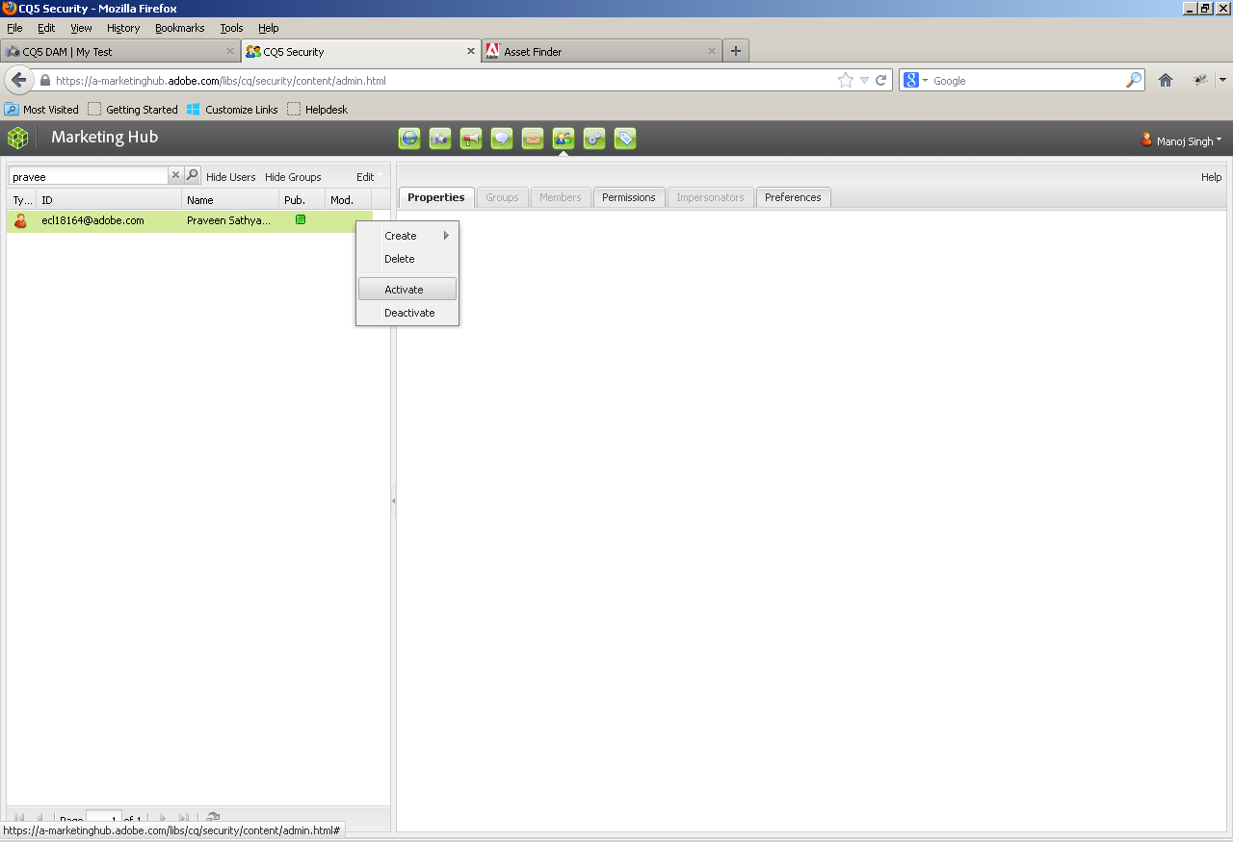

Figure 88: User Activation

1. In case the user has account in the system but doesn’t appear in the asset owner list/drop down. Please follow above instruction from the steps 10.
2. Please note that before creating any account we need to be fully thorough that the User is an Adobe employee & also we need to take approval from Rebecca to rectify any confusion.

## Checklist

Vendor Account creation -- Check list

|  |
| --- |
| **Have you used model filter to narrow the list to IMS related workflow items?** |
| **Verify if vendor has been pre-approved** |
| **Did you send an email to requester for getting Company name & Adobe Stakeholder name?** |
| **Have you checked the requestor’s name in Adobe HUB tool to categories him/her in employee type?** |
| **Did you send an approval email to the requestor’s Adobe stake holder?** |
| **Did you receive the approval email form the requestor’s Adobe stake holder?** |
| **Did you approve requestor in the MH inbox** |
| **Have you added the approval date in the requestor newly created account?** |
| **Have you sent the approval mail to Adobe stakeholder?** |

# Error messages - Canned responses

## Vendor Logging in as an Adobe Employee

The error message you received occurs when vendors (type 5 employees) attempt to log in to the Marketing Hub by way of the Adobe employee link. Currently, only Adobe employees, interns, contractors, and temporary employees (employee types 1-4 and 8) are authorized to access the Marketing Hub via this method.

Using Adobe its Worker Account Lookup Index, we confirmed your worker type is 5. Thus, you are required to access the Marketing Hub as a vendor. The steps you should follow are:

1. Go to [www.adobe.com/marketinghub](http://www.adobe.com/marketinghub).
2. Locate the login box in the right rail and click on the “Vendor Login” link.
3. On the Sign in page, enter your Adobe ID account credentials and then click Sign in.

NOTE: If you do not have an Adobe ID, you may create one of the Sign in page. If you do not remember your Adobe ID password, you may reset it by clicking the “Trouble signing in?” link.

All vendors are required to go through an account approval process to gain access to the Marketing Hub. Those who have not previously been approved for access by an Adobe employee will be placed in a temporary holding queue while a system administrator confirms the vendor’s eligibility for access.

If you have any questions or run into any further problems accessing the system, please contact us at [MarketingHub@adobe.com](mailto:MarketingHub@adobe.com).

## Search and Filters Not Visible on Asset Finder Page (Internet Explorer)

If you are using Internet Explorer, the bug you have experienced is often a result of Internet Explorer running in compatibility view. The Marketing Hub application must be used with the browser’s compatibility view turned off.

Compatibility view is easily set using the “broken page” icon on address bar. Simply click the icon to turn compatibility view on or off. If the icon is blue (as in the screenshot), compatibility mode is on. If the icon is gray, compatibility mode is off.

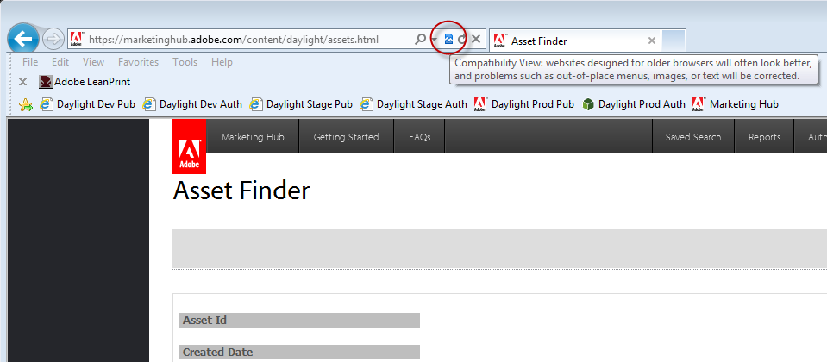

Figure 89: Compatibility view mode

If turning off compatibility view does not resolve your problem, please email [MarketingHub@adobe.com](mailto:MarketingHub@adobe.com) and the system admin team will do additional troubleshooting to determine the root cause of your issue.

Currently, Firefox is the most stable browser for the Marketing Hub.

## Downloads Appear to Disappear

Internet browsers will prevent Marketing Hub download message windows from appearing, if the browser is configured to block pop-up windows. Please check your browser settings to ensure that your pop-up blocker is enabled for the Marketing Hub site.

If you make any adjustments to the browser settings in order to allow pop-ups for the Marketing Hub site, please initiate the asset download again. (Note: The download message window does not always immediately appear after allowing pop-ups. It will appear by starting the download again.)

If you have confirmed that your pop-up blocker is enabled for the Marketing Hub site and the download still does not appear to process, please email [MarketingHub@adobe.com](mailto:MarketingHub@adobe.com) and the system admin team will do additional troubleshooting to determine the root cause of your issue.

# Employee user support - Canned responses

## Internal Login Instructions

All Adobe employees, interns, contractors, and temporary employees (employee types 1-4 and 8) automatically have access to the Marketing Hub to search for and download digital assets or run digital asset reports.

To access the Marketing Hub, please follow these simple steps:

1. Go to <http://www.adobe.com/marketinghub>
2. Locate the login box in the right rail and click on the “Employee Login” link.
3. On the Adobe Open Single Sign On page, enter your Adobe LDAP user name (i.e. jsmith) and your 4-digit PIN plus a one-time password (OTP) generated by your hardware or soft token.
4. Select Login.

NOTE: Supported browsers are Firefox and Internet Explorer. Chrome and Safari are expected to work, but are not fully supported. Pop-ups must be enabled or turned off to download assets.

If you experience any problems logging in, please email a screenshot of your exact error to [MarketingHub@adobe.com](mailto:MarketingHub@adobe.com).

## How Do I Get an OTP Token and Create a PIN?

Because of IT’s mandate that the Marketing Hub use strong authentication and single sign-on (SSO), if you need to access any of the assets in the Marketing Hub, you need a one-time password (OTP) token and a 4-digit pin.

For step-by-step instructions on how to obtain and activate OTP tokens, read the Knowledge Center article [*One-time Password Token for Windows and Macintosh OS X*](https://kc.corp.adobe.com/kc/article.cfm?id=IT00683.xml). After your token is activated, you need to log onto <http://adobeotp.adobe.com> to set your PIN.

If you run into any problems with ordering or activating your token and/or setting your PIN, please contact the IT service desk. After you have validated that your OTP token and pin are active, if you have any problems logging into the Marketing Hub, please contact us at [MarketingHub@adobe.com](mailto:MarketingHub@adobe.com).

## How Do I Change my PIN?

To change your PIN please do the following:

1. Go to <http://adobeotp.adobe.com>.
2. Log in using your LDAP login ID and password.
3. Confirm your identity by entering a security code from your one-time token that has already been registered to your account.
4. Click the Change link within the PIN box.
5. Complete the Current PIN, New PIN and Confirm New PIN fields.
6. Click Submit.

If you have forgotten your PIN or run into problems changing your PIN, please contact the IT Service Desk.

## Request for Premium Access/Full License

Due to license limitations, Premium access is restricted. If you believe you will be creating new assets or will need to publish new assets to the Marketing Hub, please send an email request explaining your need for an account upgrade to [MarketingHubTraining@adobe.com](mailto:MarketingHubTraining@adobe.com).

Note, to use the Premium access functionality, you will need to complete training for the specific system role you have been assigned. Upon receipt of your email request, a Marketing Hub team member will be in touch with details about the specific trainings you must take. As you will not be granted Premium access until the required training has been completed, feel free to search, view, and download assets via Standard access.

# Vendor user support - Canned responses

## Vendor Request for Access

The Marketing Hub is only available externally to Adobe-approved marketing/design vendors (under NDA) that are working on an Adobe project for an internal team. Consequently, all vendors are required to go through an account approval process to confirm his or her eligibility.

To begin the account approval process:

1. Go to [www.adobe.com/marketinghub](http://www.adobe.com/marketinghub).
2. Locate the login box in the right rail and click on the “Vendor Login” link.
3. On the Sign in page, enter your Adobe ID account credentials and then click Sign in.
4. Enter your agency name and the name of your primary Adobe stakeholder (an Adobe employee) who can confirm your eligibility for access on the form that appears.

NOTE: If you do not have an Adobe ID, you may create one on the Sign in page.

The Marketing Hub is not available to vendors still going through the approval process or partners, resellers/distributors, user groups, customers, or press. If you fall into one of these categories, your access will be denied, as you should obtain assets from the appropriate partner site or pressroom.

If you have any questions, please email [MarketingHub@adobe.com](mailto:MarketingHub@adobe.com) for further assistance.

## Request to Stakeholder for Confirmation of Vendor Eligibility by Adobe Contact - 1

We received a request from [user name] of [vendor name] for access to the Marketing Hub.  The site is only available externally to Adobe-approved marketing/design vendors (under NDA), who are working on an Adobe project for an internal team.  Would you confirm that this is one of your vendors and they meet those requirements? Once we have your approval, we will follow the appropriate steps to create a new account in the Marketing Hub.

Please note that Marketing Hub is not available to vendors still going through the approval process or partners, resellers/distributors, user groups, customers, or press - they should be directed to the appropriate partner site or press room.

## Request to Stakeholder for Confirmation of Vendor Eligibility by Adobe Contact - 2

This is just a quick reminder that we received a Marketing Hub account request from [user name] of [vendor name]. As the site is only available externally to Adobe-approved marketing/design vendors (under NDA), your confirmation that [user name] is eligible for access is required before access can be granted. So we can move forward with the suitable action, please let us know at your earliest convenience if [user name] is one of your vendors and meets the requirements for access.

## Request to Stakeholder for Confirmation of Vendor Eligibility by Adobe Contact - 3

[User name]’s Marketing Hub account request is still pending; as we have yet to receive your confirmation that [user name] is eligible for access to the site. Please let us know within the next 3 business days if you confirm [user name]’s eligibility. If no response is received, we will deny [user name]’s access to the system and close out the pending account request.

As a reminder, the Marketing Hub site is only available externally to Adobe-approved marketing/design vendors (under NDA), who are working on an Adobe project for an internal team. The Marketing Hub is not available to vendors still going through the approval process or partners, resellers/distributors, user groups, customers, or press - they should be directed to the appropriate partner site or press room.

## Reply to Stakeholder after Confirmation Received (& Vendor Account Approved)

Thank you for your confirmation. [User name]’s access has been granted.

## Account Request Workflow Missing Details

* + - 1. Workflow notification received, go to MH Inbox and open Work Item
      2. Are company name and approved by (stakeholder name) missing?
      3. If NO - Follow standard account approval process
      4. If Yes – Please send “Vendor Request for Company & Stakeholder Info” mail
      5. Check – Did user respond?
      6. If Yes –

1. Please check was missing info provided. If user provided the missing info, then follow standard account approval process.
2. If missing information not provided, then deny the request and send “Vendor Request for Access Denied Due to Incomplete Info & No Response from Requestor”
   * + 1. If No –
3. After 48 hours, send “Vendor Request for Company & Stakeholder Reminder” mail.
4. Check user respond & provided missing info after reminder mail? If YES, then follow standard account approval process. If No, then deny the request and send “Vendor Request for Access Denied Due to Incomplete Info & No Response from Requestor”

## Vendor Request for Company & Stakeholder Info

We are unable to act on your request for access to the Marketing Hub, as required information is missing from your submission. Please provide us with your company name and the name of your primary internal Adobe contact so a system administrator can validate your eligibility for access. If your request was generated accidentally, please let us know and we’ll close it.

## Vendor Request for Company & Stakeholder Reminder

Your request for access to the Marketing Hub is still pending. Please provide us with your company name and the name of your primary internal Adobe contact so a system administrator can validate your eligibility for access. If we do not hear from you within 48 hours, we will proceed with denying your account request.

## Vendor Request for Access Denied Due to Incomplete Info & No Response from Requestor

The Marketing Hub site is only available externally to Adobe-approved marketing and design vendors (under NDA), who are working on a project for an internal team. Over the last few weeks, we tried to contact you several times to obtain your company name and internal Adobe contact so we could confirm your eligibility. As our queries have gone unanswered, your access to the Marketing Hub has been denied.

If you need entry to the Marketing Hub in the future, you may petition access by emailing [MarketingHub@adobe.com](mailto:MarketingHub@adobe.com). In your message, please include the following: your name, Adobe ID, company name, and internal Adobe contact.

## Vendor Request for Access Denied by Stakeholder

Your request for access to the Marketing Hub has been denied.

The Marketing Hub site is only available externally to Adobe-approved marketing and design vendors (under NDA), who are working on a project for an internal team. Your Adobe stakeholder, [insert name of stakeholder], informed us that you do not meet these requirements.

Registered partners should obtain partner approved assets via the portal or other method identified in their program membership materials and should contact their program Help Desk or partner manager with questions. User groups, customers, or press should refer to the press room.

## Vendor Request for Access Denied Due to No Response from Stakeholder

The Marketing Hub site is only available externally to Adobe-approved marketing and design vendors (under NDA), who are working on a project for an internal team. We have reached out to the Adobe stakeholder you provided us several times over the last few weeks to obtain confirmation that you are eligible for access, but our queries have gone unanswered. Consequently, your access to the Marketing Hub is being denied.

If you are still in need of accessing the Marketing Hub, please provide us with the name of another internal Adobe stakeholder who will be able to confirm your eligibility.

## Reset a Vendor Password

The Marketing Hub admin team is unable to reset your Adobe ID password. To reset your password:

1. Click on the “Trouble signing in?” link found on the Sign in page.
2. Enter your Adobe ID in the email address box and click reset password.
3. An email will be sent to the email address entered. Follow the instructions in the received email to reset your password.

Please contact [MarketingHub@adobe.com](mailto:MarketingHub@adobe.com) if you experience any further problems.

## Vendor can’t log in using IE10

If you have trouble logging in to the Marketing Hub using Internet Explorer 10, please follow these steps:

1. In IE10, click the Tools icon at the top right.
2. Click “Internet Options” in the drop-down menu.
3. In the Internet Options window that appears, click the “Advanced” tab.
4. Uncheck the “Use software rendering instead of GPU rendering*” box, under “Accelerated graphics.”

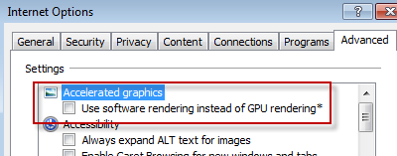

Figure 90: Compatibility view mode

1. Click “OK.”
2. Restart your machine, and log in to the Marketing Hub.

If you have any questions or still experience difficulty logging in, please email [MarketingHub@adobe.com](mailto:MarketingHub@adobe.com) for further assistance.

## For Generic Account (Name & Email ID)

We have denied your account request because data you provided is not as per the standard. You used generic name (**Xcel Agency**) and generic email id (**XXXX@xcelagency.com**). Adobe policy doesn’t allow use of generic Adobe ID account that is shared. Use of generic account such as **XXXX @xcelagency.com** prohibit us from being able to properly track asset usage, user behavior in the system and completed training.

Please note that as per Marketing Hub policy each user needs to be approved for access Marketing Hub and log in via his or her own account as sharing of account credential is highly prohibited. Vendors should not be sharing Marketing Hub accounts. Sharing accounts is against adobe policy and request that each individual who needs access to the Marketing Hub submit requests for their own accounts.

Just to inform you need to resubmit the request using Adobe IDs unique for each user(s).

## Sharing MH Accounts

Vendors should not be sharing Marketing Hub accounts. Sharing accounts is against adobe policy and request that each individual who needs access to the Marketing Hub submit requests for their own accounts.

We ask this for two reasons –

1) To ensure that we keep an accurate audit trail of exactly who is downloading what

2) To ensure that we can communicate critical updates to all users

## Partner Portal

We are sorry to say that we would not be able to provide you access to Marketing Hub. As Marketing Hub site is only available externally to Adobe-approved marketing and design vendors (under NDA), who are working on a project for an internal team.

**Registered partners** should obtain partner approved assets via the portal or other method identified in their program membership materials and should contact their program Help Desk or partner manager with questions. User groups, customers, or press should refer to the [press room](https://namail.corp.adobe.com/owa/redir.aspx?C=ptsZlWv29kax2SUOzt__K_J13K6s7M9Ib_Izc-zAuVCEBzG3s0vqBc7EXr5ZJgEt6Vu14yRro4g.&URL=https%3a%2f%2fnamail.corp.adobe.com%2fowa%2f%3fae%3dPreFormAction%26a%3dForward%26t%3dIPM.Note%26id%3dRgAAAAA40sjjmKLRRKl%252bBbGmrMHlBwC5DFBx3M8yT6QQV9L0dvpSAAAJYhGNAAC5NGIGNl4oRa95d7%252bbNVzeAEuMX%252fFhAAAJ%23http%3a%2f%2fwww.adobe.com%2faboutadobe%2fpressroom%2fpressmaterials%2f).

# Publisher user support - Canned responses

## Error when Creating a Folder

Asset publishers do not have the ability to create folders in the Marketing Hub. If you need a folder created in the system to be able to upload your asset(s), please submit a [New Folder Request](https://adobeformscentral.com/?f=Cs9lMyNaLFZkJWS3JIxwZQ) to the Marketing Hub team and a system administrator will create the folder for you.

If you have any questions or problems with the form, please contact us at [MarketingHub@adobe.com](mailto:MarketingHub@adobe.com).

## Error when Deleting an Asset

Asset publishers do not have the right to delete assets from the Marketing Hub; only the system administration team has this ability. Please let us know what asset(s) need to be deleted and a system administrator will complete the task on your behalf.

## Error when Moving an Asset

Asset publishers do not have the ability to move assets from one folder to another; only the system administration team can move assets. Please let us know what asset(s) need to be moved and where they should be moved to and a system administrator will complete the task on your behalf.

# Publishing questions - Canned responses

## How can I get new asset published to the Marketing Hub?

Please submit a [Marketing Hub Publishing Request](https://adobeformscentral.com/?f=zSb48VFPfUIjKZjBCadyRA) a system administrator will post the asset to the system on your behalf. If you have any questions or problems filling out the form, please email [MarketingHub@adobe.com](mailto:MarketingHub@adobe.com).

## How do I get my assets published to Partner Portal and/or Readiness Portal?

The Content Delivery team runs a report every Monday to identify new and/or updated assets published to the Marketing Hub during the previous week that were flagged “yes” for Publish to Partner Portal and/or Publish to Readiness Portal.

For all assets destined for the partner portal and many assets destined for Infield, metadata is required that the Marketing Hub does not capture. In those cases the Content Delivery team will send to the asset owner (as identified in the Marketing Hub) a review and release form to be completed and returned.  Assets will be uploaded and released within approximately 24 hours of receiving the completed form.

If you don’t want to wait for the weekly report to initiate the publishing process, you may proactively submit the review and release form to the Content Delivery team. The team will then process the request at the next available opportunity, usually within 24 hours after receiving the completed form. You can find the form and relevant instructions on the [Content Delivery Team’s wiki](https://zerowing.corp.adobe.com/display/infield/Publishing+Assets+to+InField+and+the+Partner+Portal#PublishingAssetstoInFieldandthePartnerPo). Questions for the Content Delivery team should be sent to DL-PP-content-admin.

## How do I publish assets to the Marketing Hub?

In order to maintain data quality within the Marketing Hub, posting assets to the Marketing Hub is restricted to Certified Asset Publishers. To learn more about the Asset Publisher certification process, read the [program overview](http://www.adobe.com/marketinghub/pdfs/Outline_of_Publisher_Certification_Program.pdf).

If you believe you qualify and wish to begin the Asset Publisher Certification program, send an email to [MarketingHubTraining@adobe.com](mailto:MarketingHubTraining@adobe.com). In the email, please estimate how frequently you will be posting and/or modifying assets as well as the types of assets you’ll be posting most often.

If you do not meet the criteria to complete the Asset Publisher Certification program or don’t have time to complete the program at this time, please submit a [Marketing Hub Asset Publishing Request](https://adobeformscentral.com/?f=zSb48VFPfUIjKZjBCadyRA) and a member of the system administration team will post the asset(s) on your behalf.

# Ad-hoc Task

## Expired Users - External

The Expired User service, which runs once a night, looks at all system users and applies the “Expired User” group to anyone that has not logged in to the Marketing Hub in the last six months. It will also remove the user from this group if they were previously added but have logged in.

Once a month, we need to run the new expired users report to pull all external users who have not logged in within the last six months and then blacklist the users.

Here are the specifics:

1. In Log in to the Marketing Hub author instance and navigate to the

Classic UI.

1. From the Classic UI home page, click **Tools**. Expand **Reports > Marketing**

**Hub > Admin Reports**.

1. Double click on **Expired Users - External** to run report. Click **Download**

**CVS** to export the report generated.

1. Open the exported document in Excel. Activate filters to the column

Header row.

1. Apply the following filter: **Group Membership (Direct) does not contain**

**Blacklist.**

1. Return to the Marketing Hub and navigate to Users.
2. Look up the first user in the filtered excel list document, apply the

**Marketing Hub Blacklist** user group and then activate the user record. Repeat this step for all in the users in the filtered excel list. When all users have been added, activate the Marketing Hub blacklist group.

1. Email the user to alert the user that his/her permissions to the

Marketing Hub have been revoked.

# Registered Partner Questions - Canned responses

## Can my partner get access to the Marketing Hub?

Many assets stored in the Marketing Hub are meant for Adobe’s use only. Consequently registered partners are not authorized access. They should obtain partner approved assets via the portal or other method identified in their program membership materials and should contact their program Help Desk or partner manager with questions.

# Tips and Tricks

## Asset download from Asset Finder

Below are the steps to download assets (single/multiple) from the **Download cart.**

1. Search the asset by keywords or asset Id in Asset Finder Page
2. To download single asset hover over the asset and click on download link
3. To download multiple assets as a group, in Asset Finder hover over each asset you want to download and then click the "Add rendition to Download Cart" button
4. Select the renditions you would like to download from the list. You can add as many assets and renditions as you would like to download
5. You’ll see your chosen renditions added to the Download Cart section
6. Once you have completed adding all the renditions you want, click on “Download” under the Download Cart section and you’ll be prompted to save or open the download

# Revision History

|  |  |  |  |
| --- | --- | --- | --- |
| **Name** | **Date** | **Reasons for Change** | **Version** |
| Sumit Bhawsar | 5th June 2012 | Document Creation | 1.0 |
| Sumit Bhawsar | 7th June 2012 | Added standard template for e-mail communication | 1.2 |
| Sumit Bhawsar | 8th June 2012 | Added Rebecca’s comments | 1.3 |
| Manoj Singh | 7th Aug 2012 | Added updated template for e-mail communication | 1.4 |
| Manoj Singh | 5th Oct 2012 | Added updated template for e-mail communication | 1.5 |
| Manoj Singh | 11th Jan 2012 | Updated the whole SOP in accordance with new Adobe Marketing Hub (CQ5 DAM) | 1.6 |
| Manoj Singh/ Dinesh Yande | 18th July 2013 | Updated Asset Uploading & vendor account creation check lists & formatting | 1.7 |
| Manoj Singh/ Dinesh Yande | 10th Feb 2014 | Incorporated change management Event ID 53305 | 1.8 |
| Manoj Singh/ Dinesh Yande | 22nd July 2014 | WALI Tool access has been resumed so NOTE for the same has been removed Event ID: 61410 | 1.9 |
| Vinod Yadav/ Dinesh Yande | 13th January 2015 | Updated procedural step for section New Account Creation in Adobe Marketing Hub Event raised under ID 68560 | 2.0 |
| Dinesh/ Manoj | 27th April 2015 | Updated with change Adobe Marketing Hub has upgraded its AEM platform with new GUI associated to CM ID: 72364 | 2.1 |
| Manoj Singh | 14th June 2016 | Updated missing step on Asset ID – Publishing New assets in DAM | 2.1 |
| Nupur Deshmukh | 15th Sept 2016 | Updated Screenshots | 2.2 |
| Nupur Deshmukh | 7th Oct’16 | Addition of updates | 2.3 |
| Vijayrajan Nadar | 22nd Dec 2016 | SOP Updates | 2.4 |
| Vijayrajan Nadar | 25th Jan 2017 | Checklist Addition | 2.5 |
| Vijayrajan Nadar | 26th May 2017 | Addition of Language | 2.6 |
| Dhanashree Dalvi | 30th May 2019 | Checklist Updated | 2.6 |

Table 6: Revision History